TEST SCENARIOS FOR AUTOMATION

|  |  |
| --- | --- |
| PO | Req creation 🡪 Req Approval 🡪 Blanket Release creation from PR 🡪 Blanket Release Approval |
| PO | Req creation 🡪 Req Approval 🡪 Standard PO creation from PR 🡪 PO Approval 🡪 PO Receipt creation |
| PO | PO creation 🡪 PO Approval 🡪 Receipt creation 🡪 Invoice creation |

1. Requisition creation 🡪 Req Approval 🡪 Blanket Release creation from PR 🡪 Blanket Release Approval

User- BRAHMEG

Responsibility – MWSPC Purchasing Power Generation

Purchasing Preparer 🡪 Requisitions

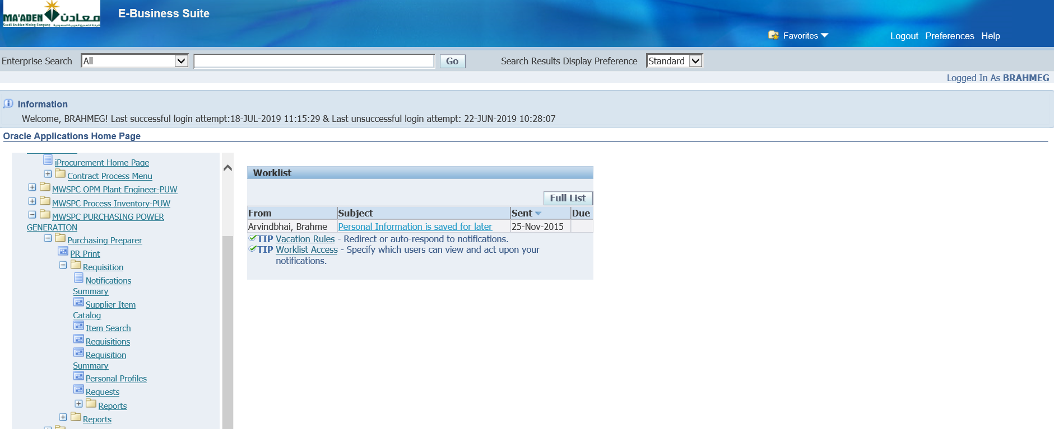

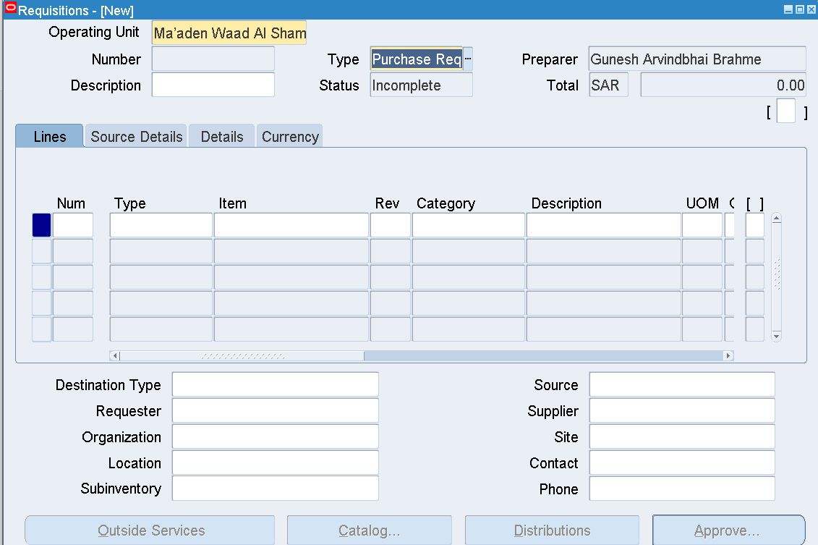

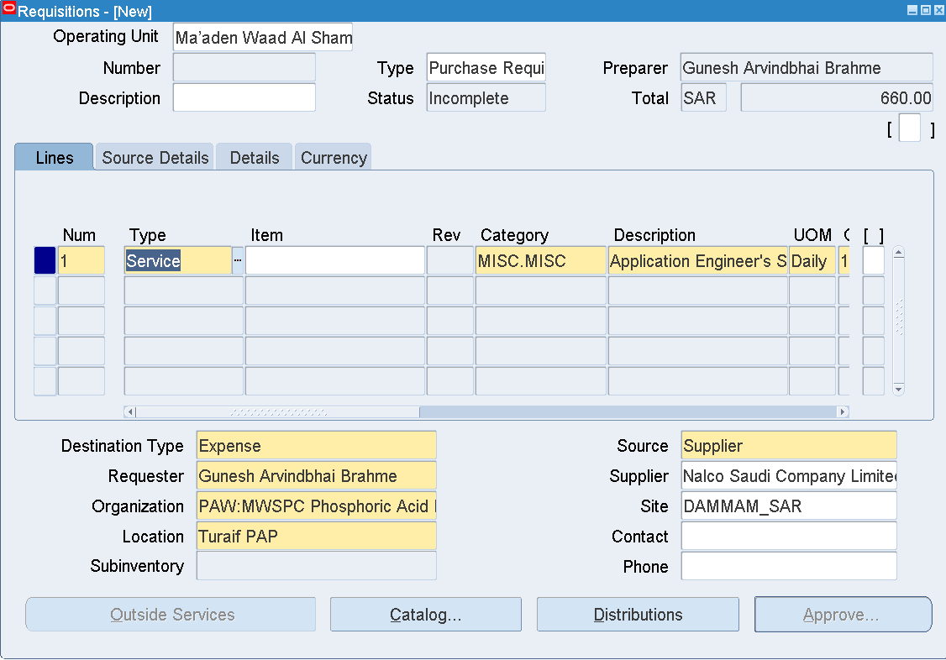

|  |  |
| --- | --- |
| Type | Service |
| Category | MISC.MISC |
| Description | Application Engineer's Service Charge |
| UOM | Daily |
| Quantity | 1 |
| Price | 660 |
| Need by Date | Any future date |
| Organization | PAW:MWSPC Phosphoric Acid Plant Warehouse |
| Location | Turaif PAP |
| Supplier | Nalco Saudi Company Limited |
| Site | DAMMAM_SAR |
| Source Details |  |
| Document Type | Blanket Purchase Agreement |
| Document | 741700202 |
| Line | 13 |

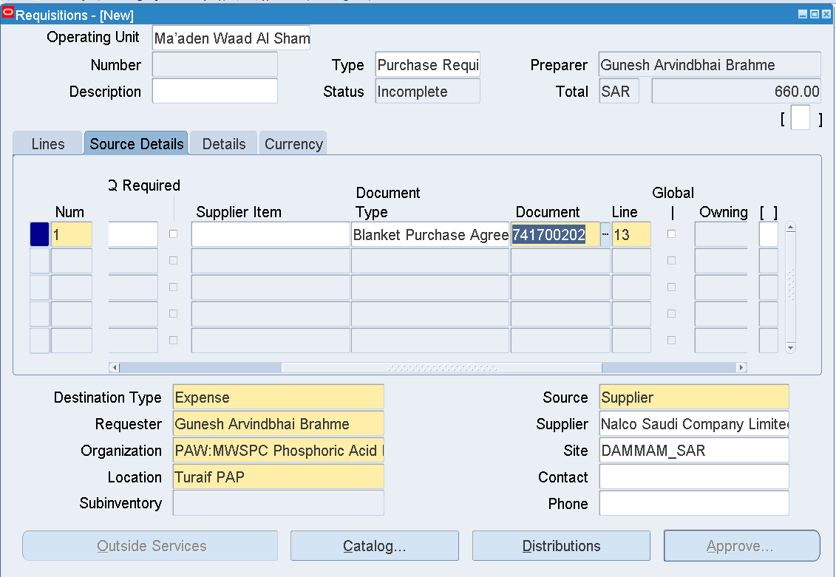

Save

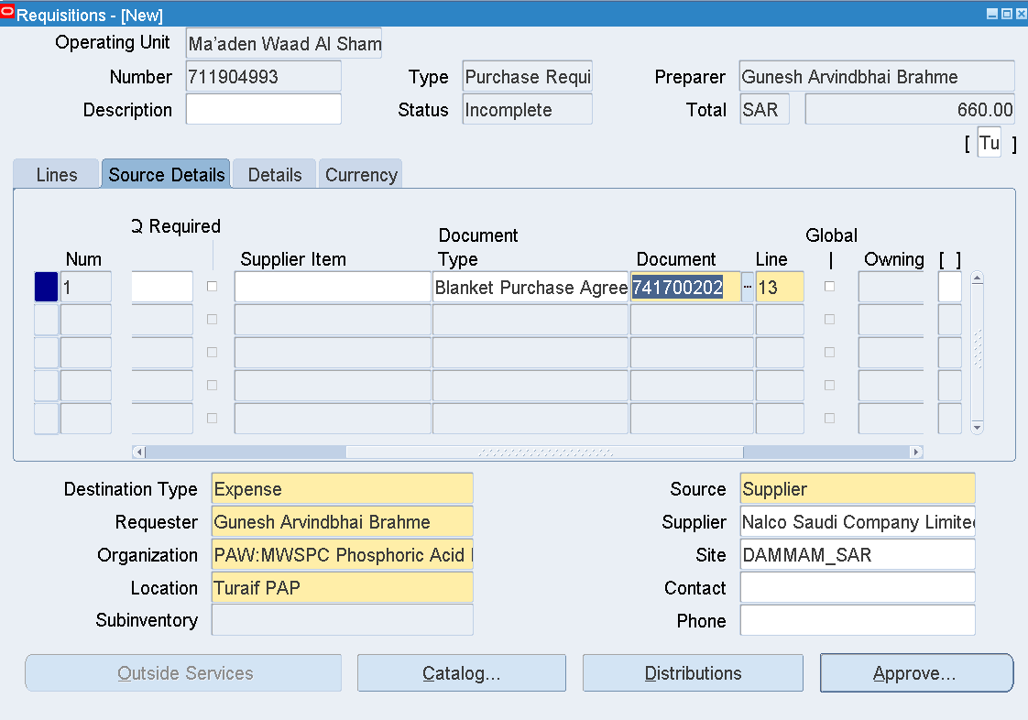

Requisition number 711904993 is generated

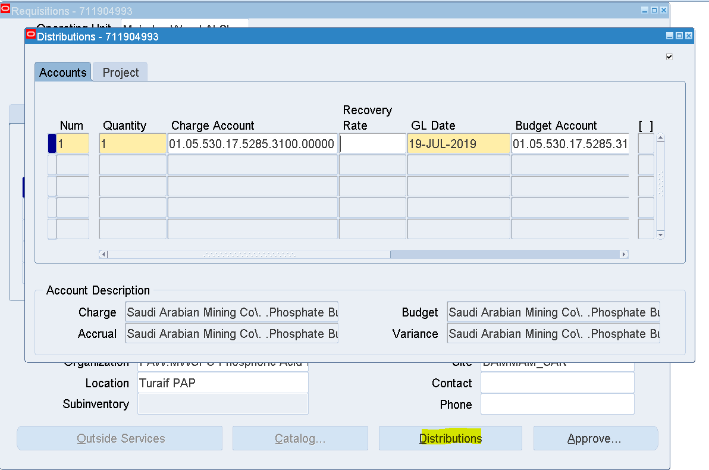

Distributions

Enter Charge Account - 01.05.530.17.5285.3100.00000

Save

Approve

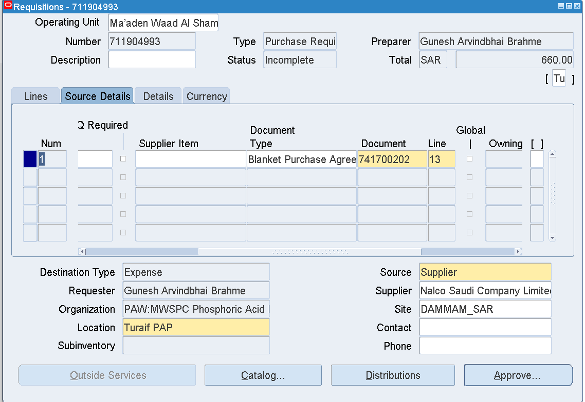

Approve

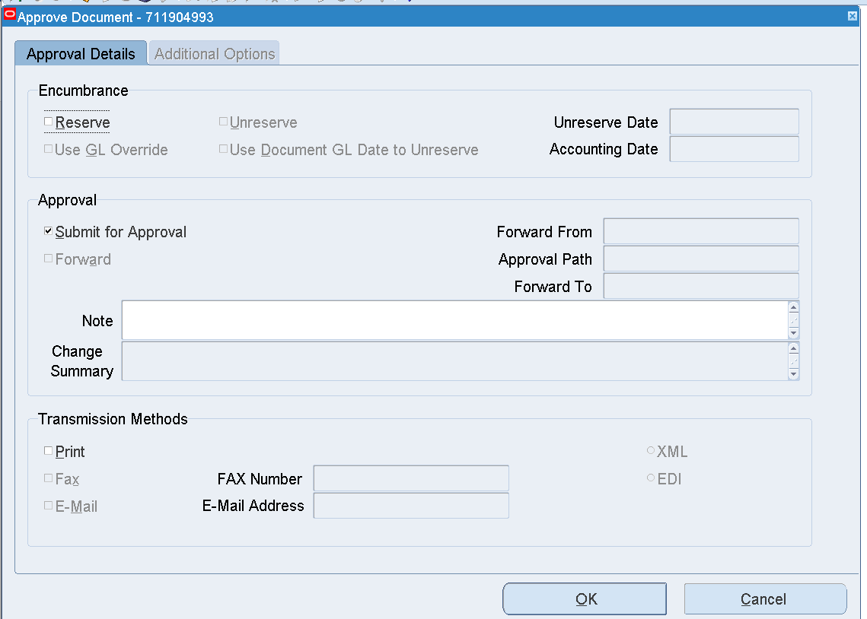

OK

Requisition – 711904993

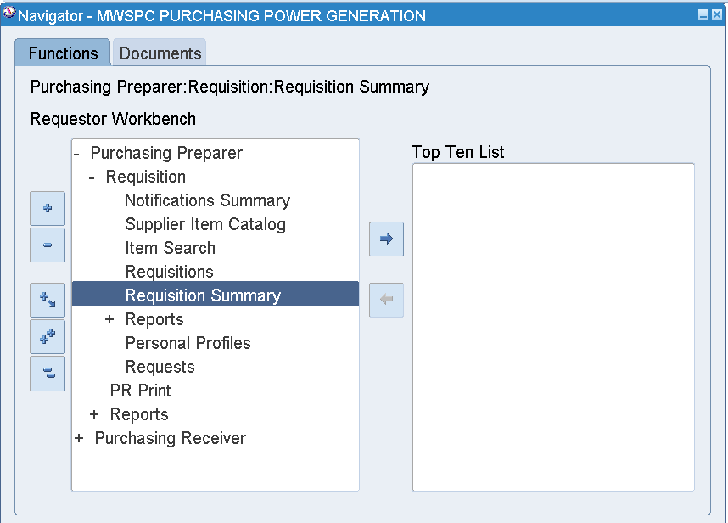

Requisition Summary

Enter Requisition Number 711904993

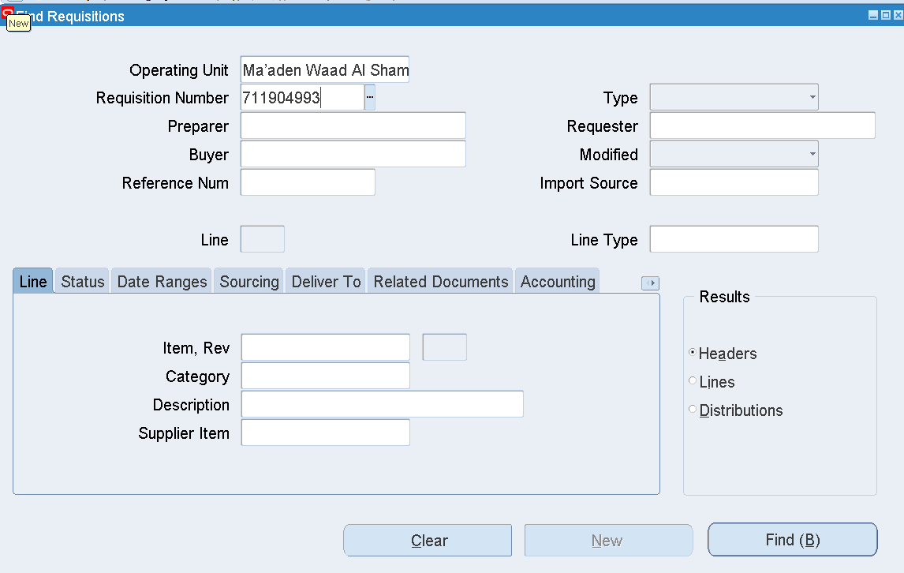

Find

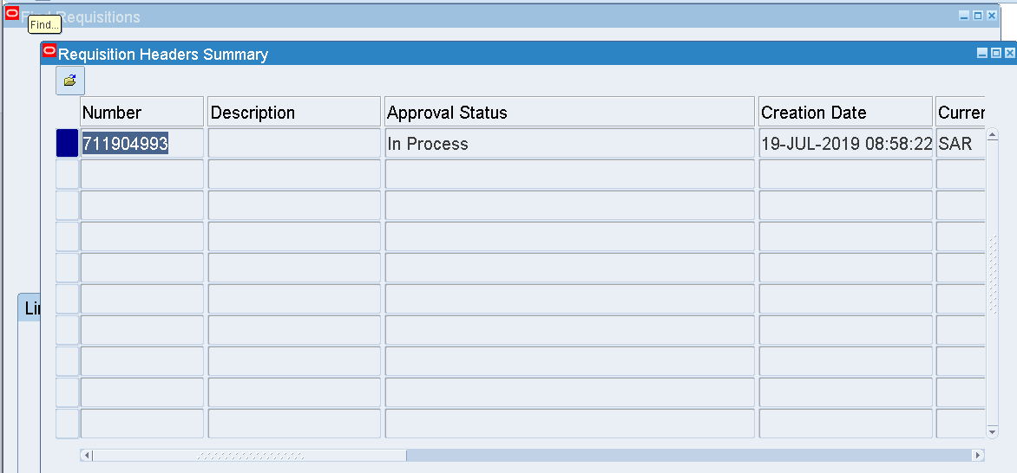

Approval Status 🡪 In Process

Tools 🡪 View Action History

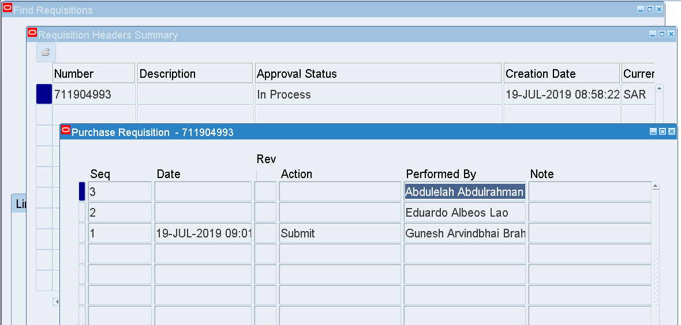

Approver - Abdulelah Abdulrahman Mohammed Alameri

Abdulelah Abdulrahman Mohammed Alameri’s User name – ALAMERIA

Login as ALAMERIA

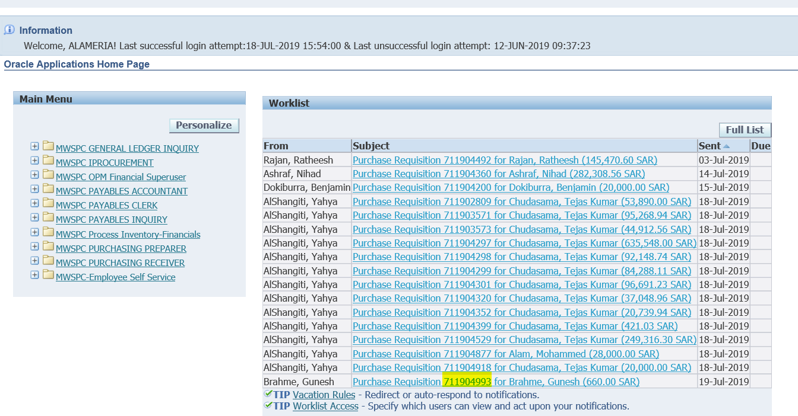

The Requisition is available in the Worklist

And awaiting Approval

Select that Link

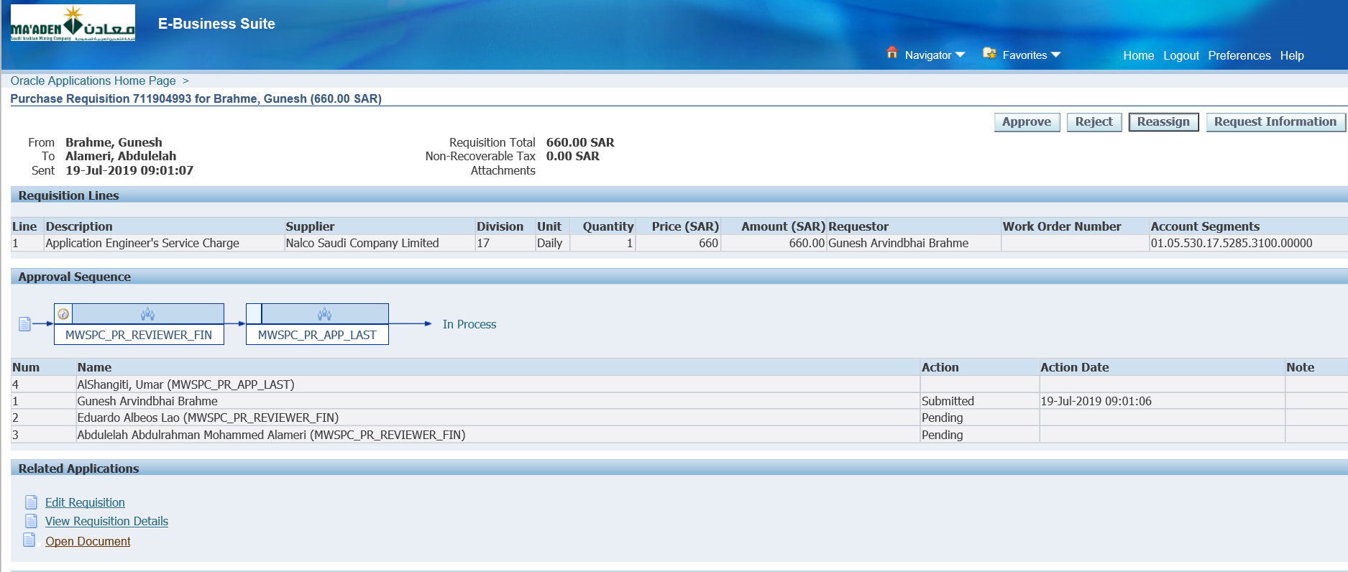

Click Approve

Then Login as Umar Khatri AlShangiti

User - SHANGITIU

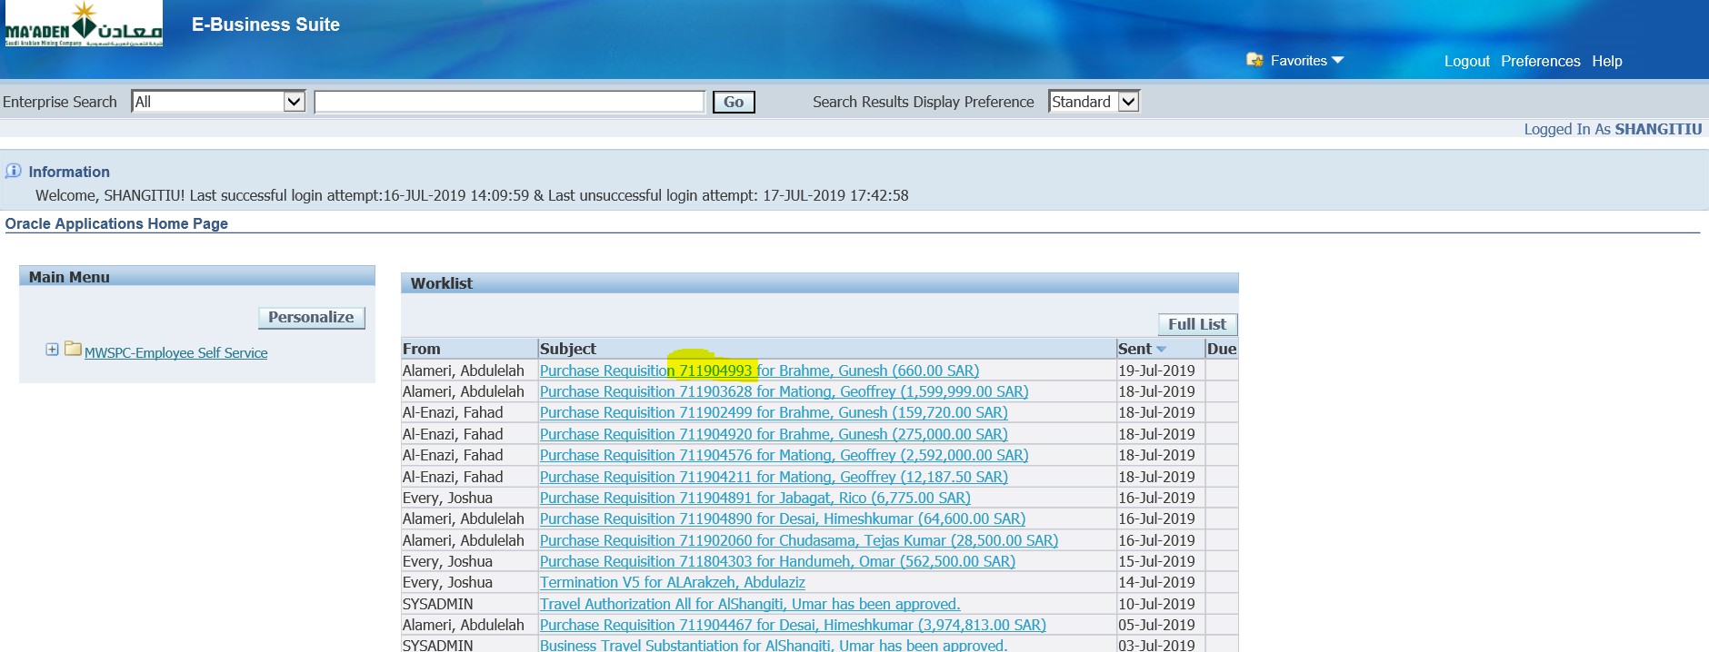

Open that Requisition from the worklist

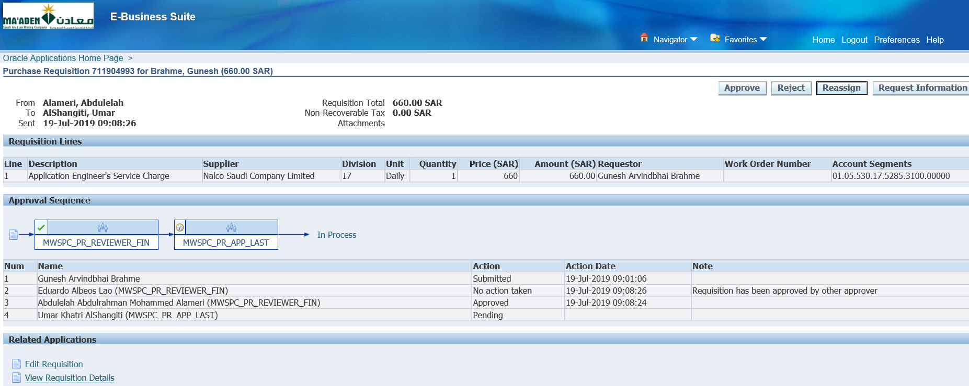

Click Approve

Once this is Approved

Login as Buyer – Shaji Peethambaran

User – PEETHAMBARANS

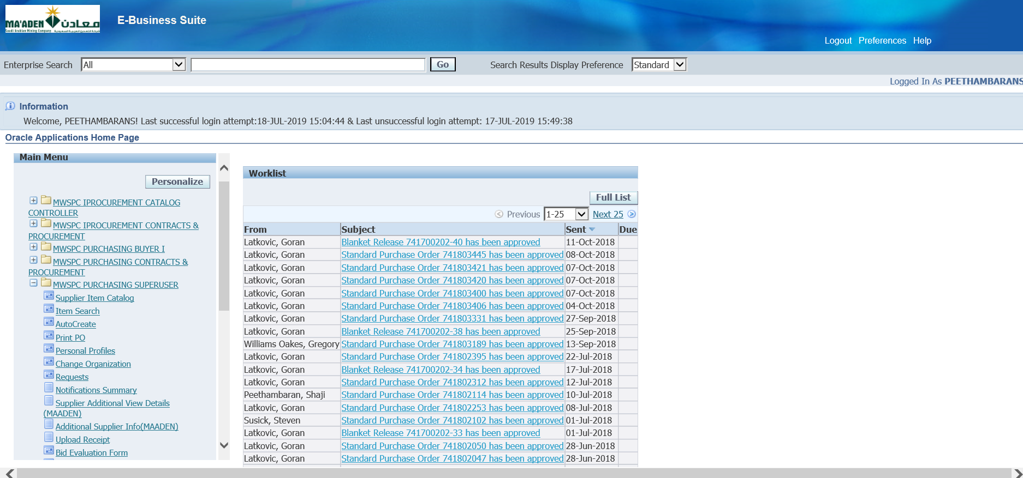

Responsibility – MWSPC Purchasing Superuser

Autocreate

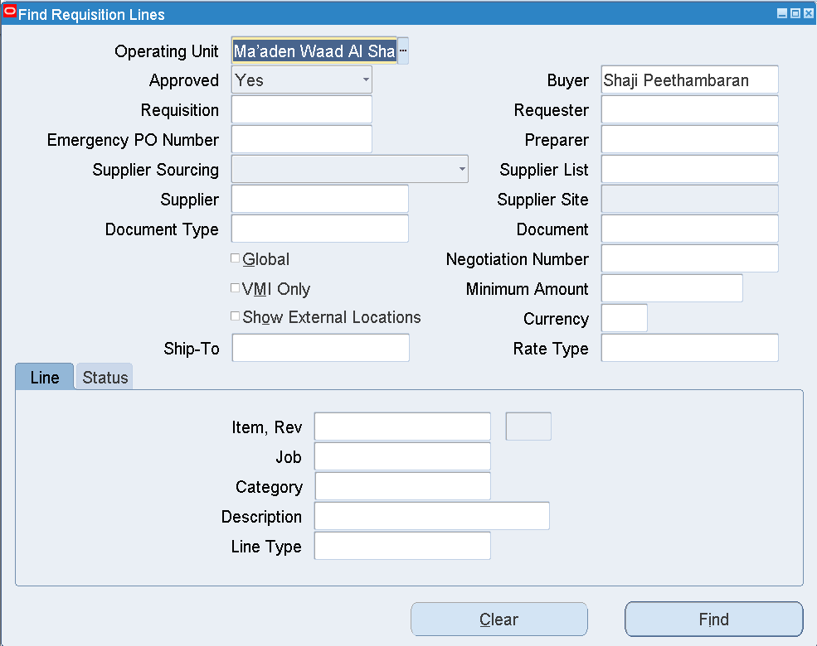

Clear Buyer

Enter Requisition number – 711904993

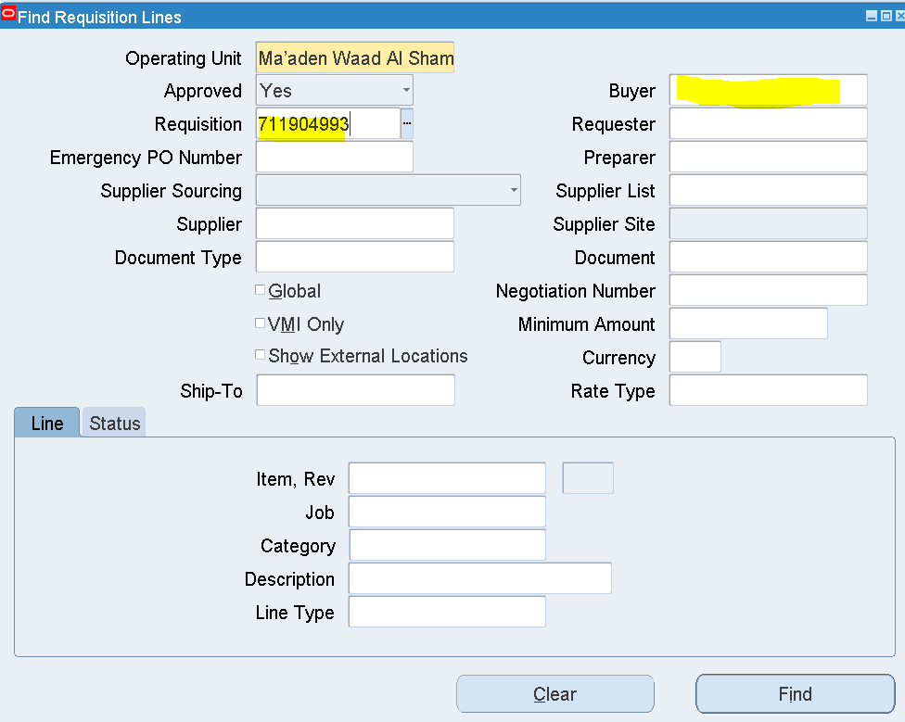

Find

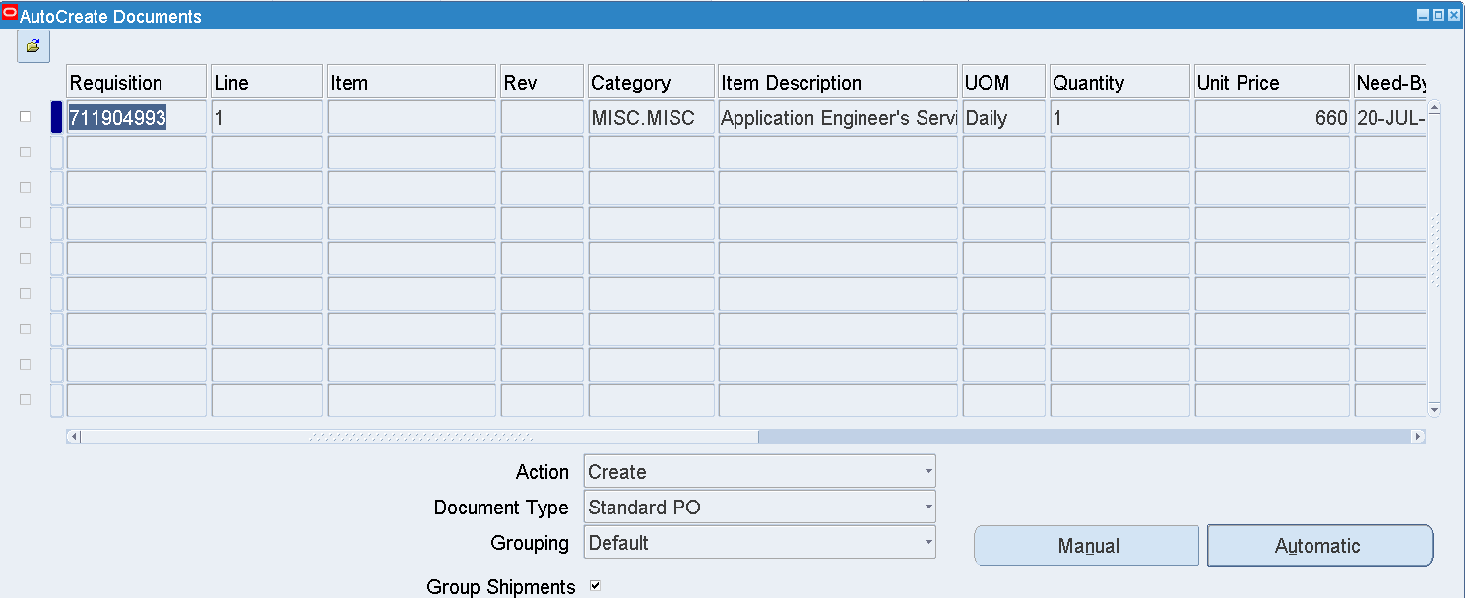

Select the Line as below

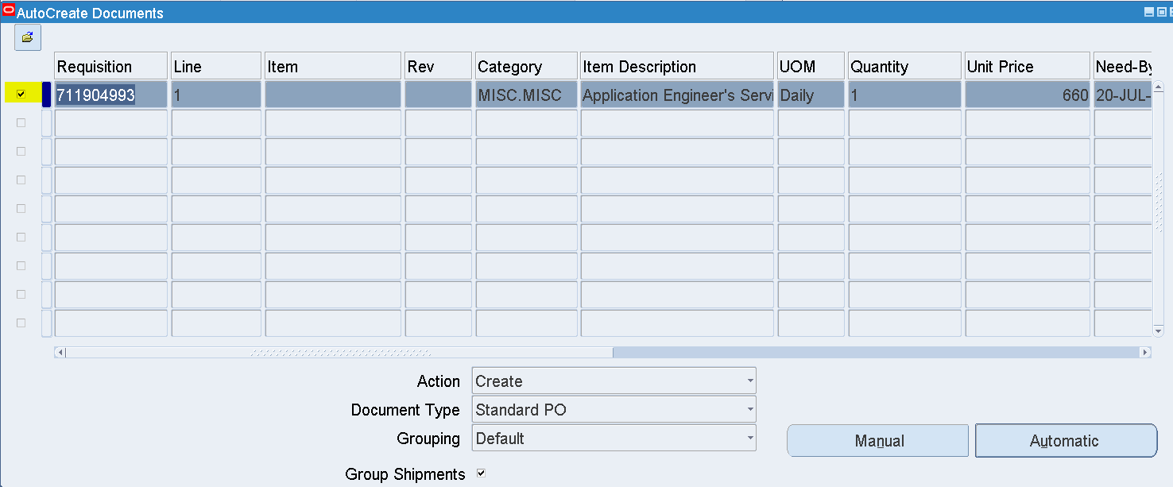

Change Document Type from Standard PO – Blanket Release

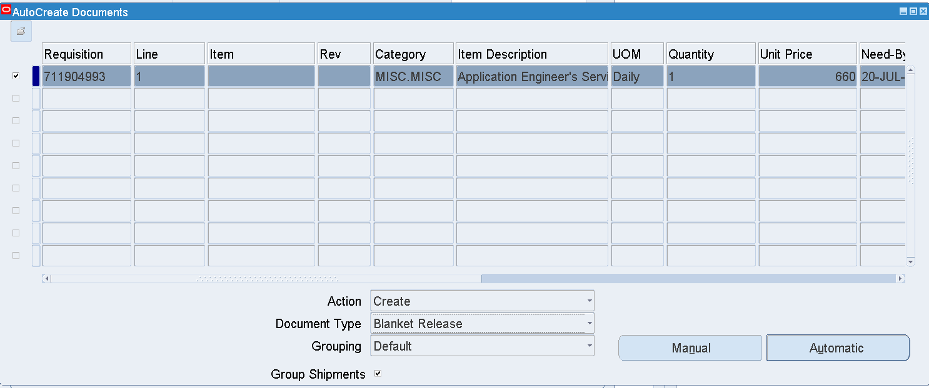

Click Manual

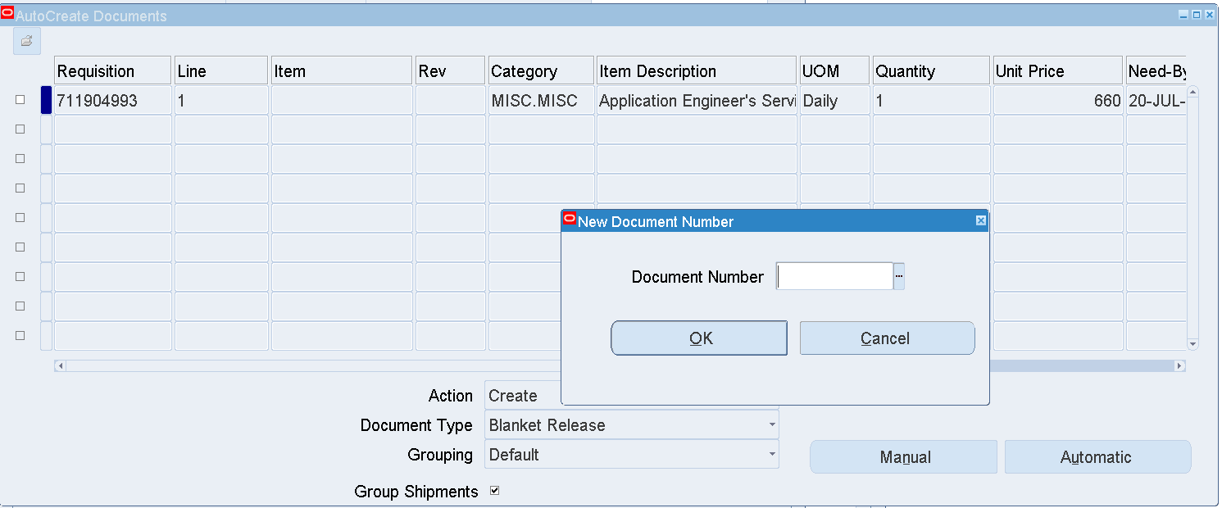

Enter BPA – 741700202

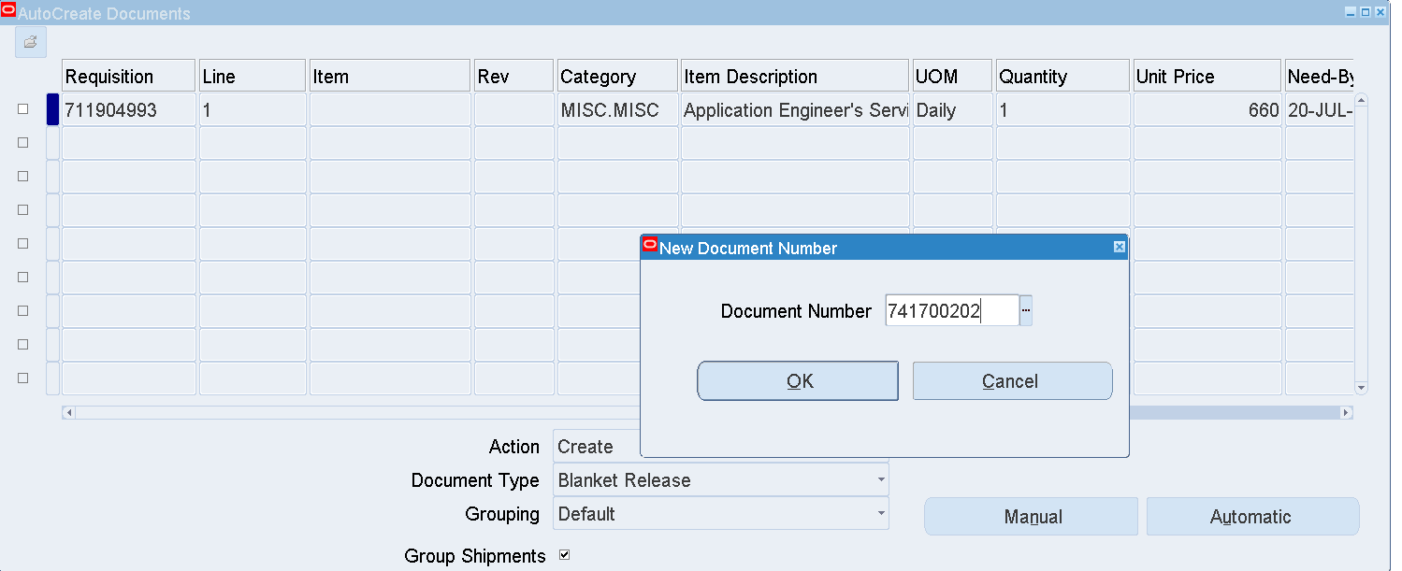

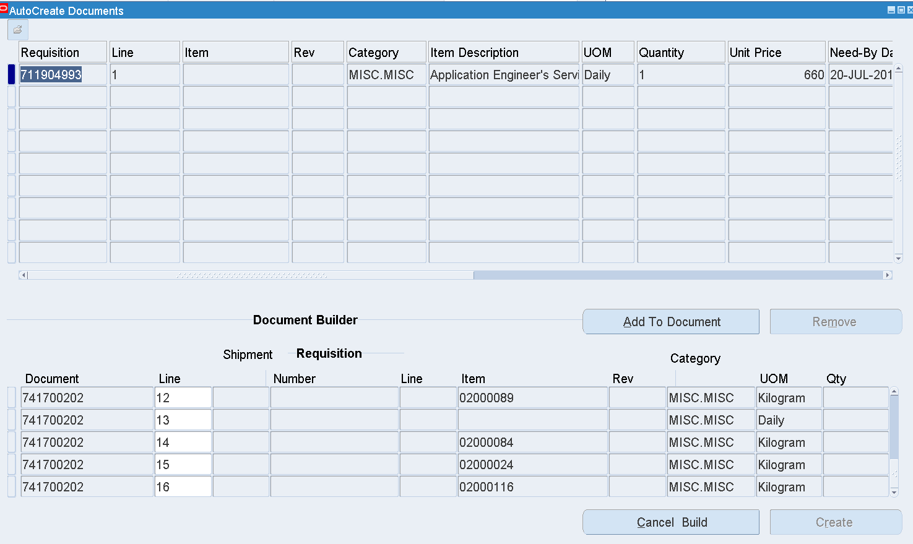

Select Line 13

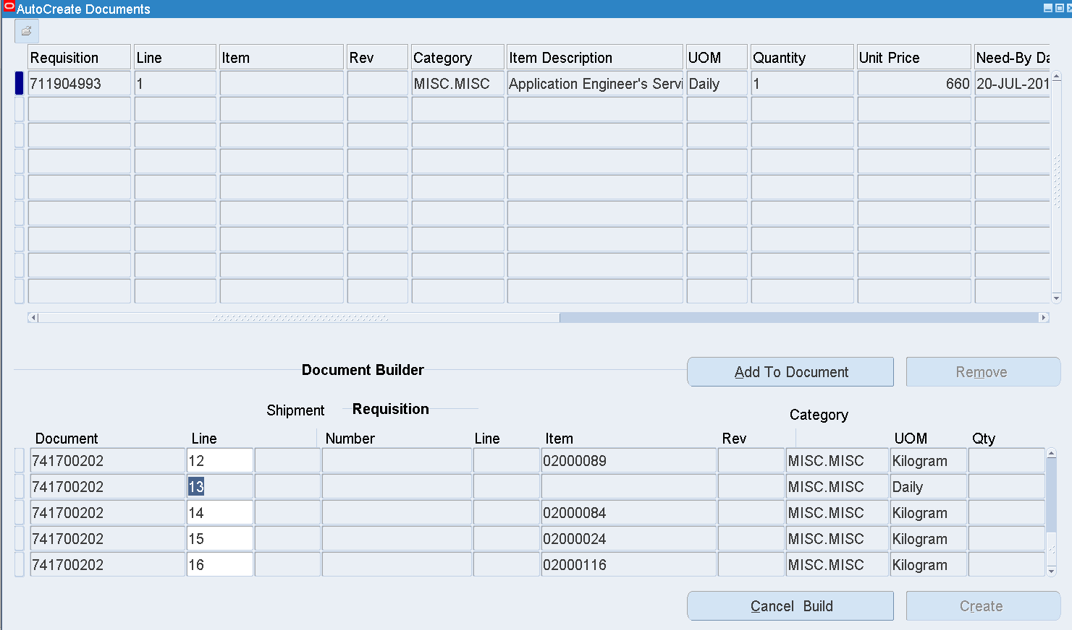

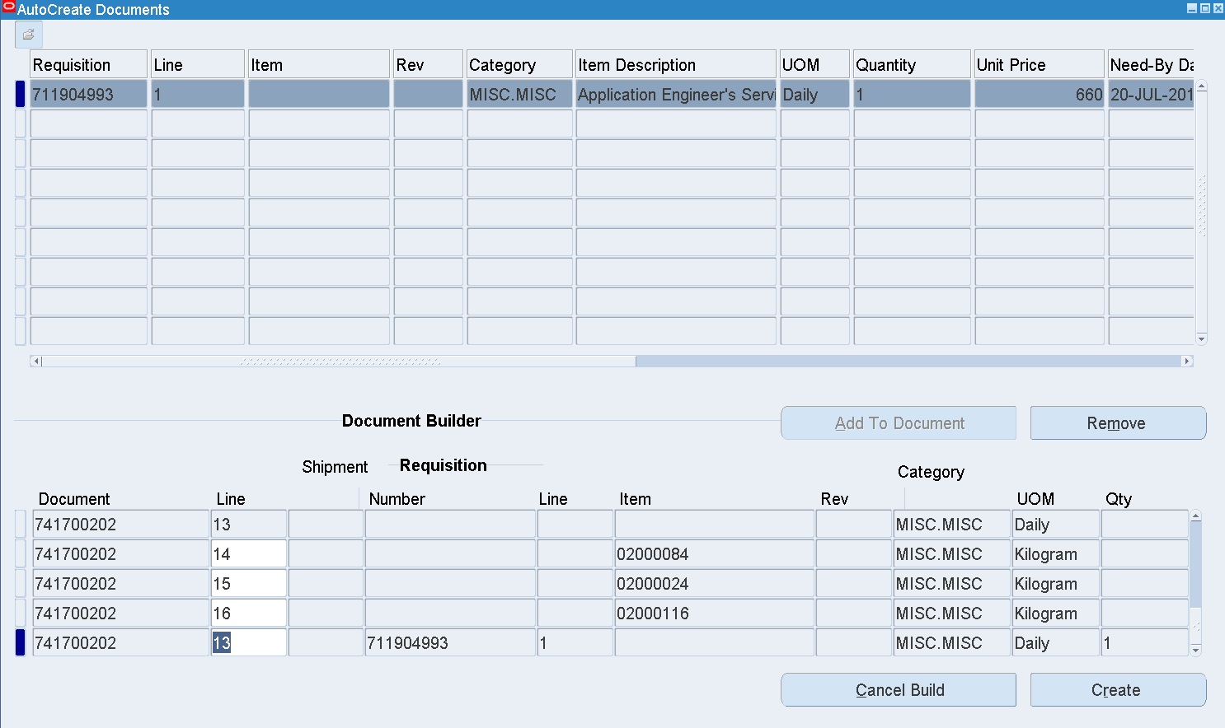

Click Create

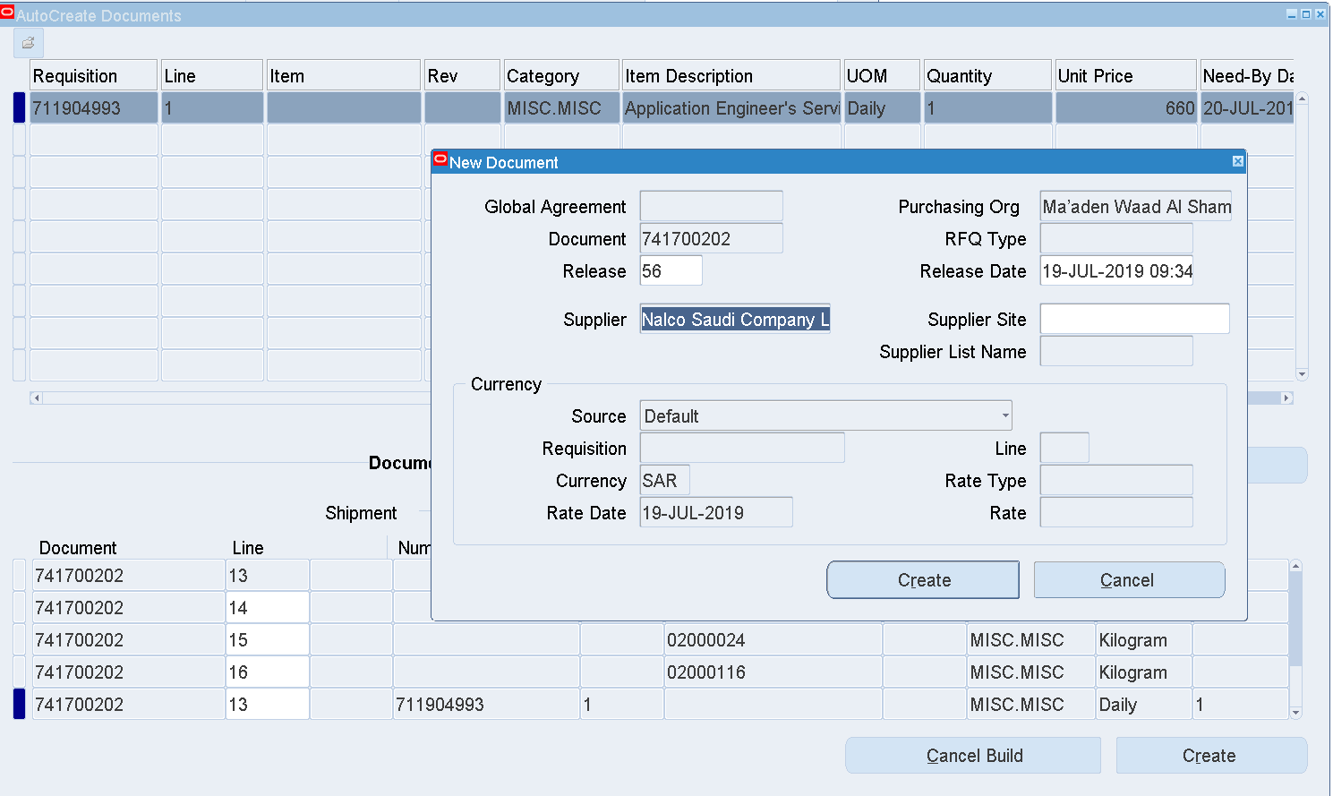

Create

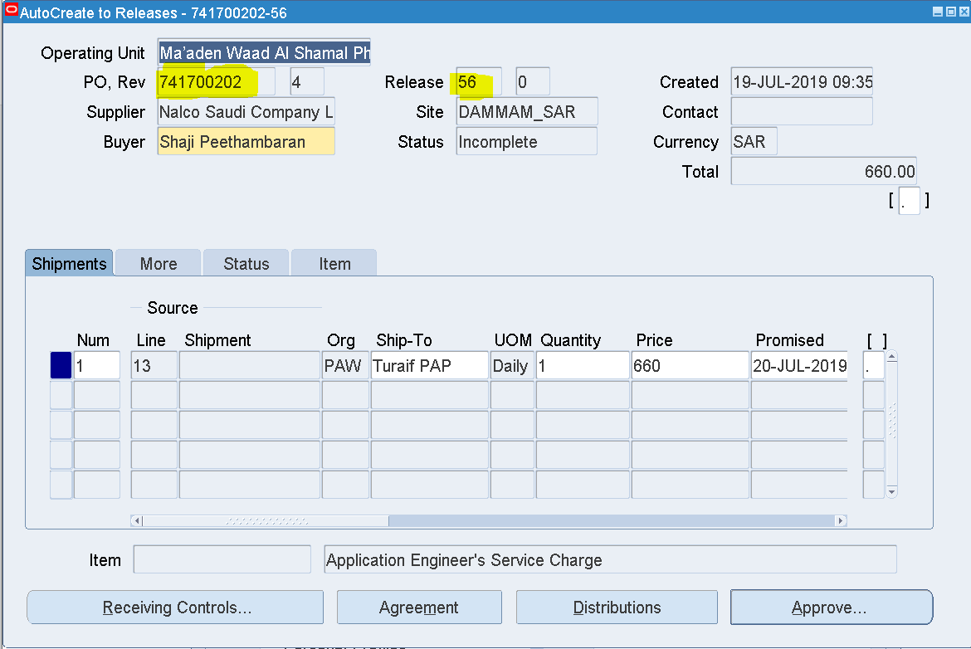

Blanket Release has been created

741700202 - 56

Click Approve

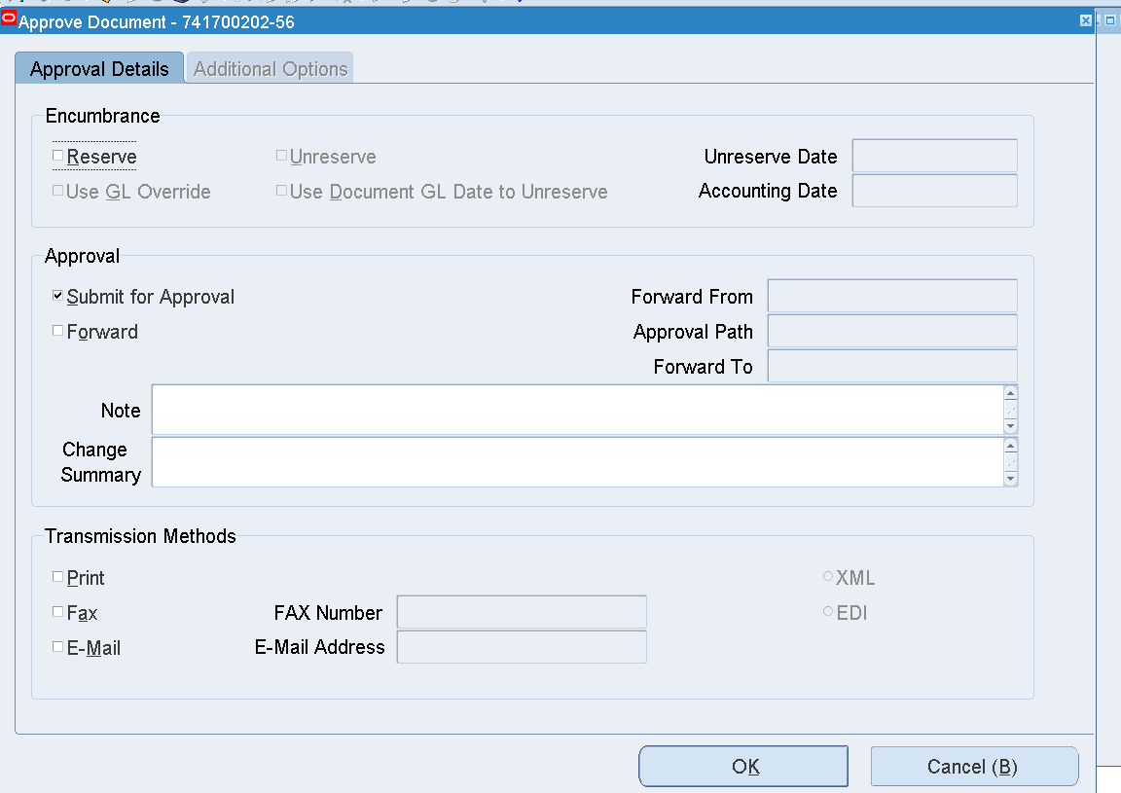

OK

Search the Purchase order Number

Purchase order 🡪 Purchase order Summary

Enter Purchase order number and Release number as below

Find

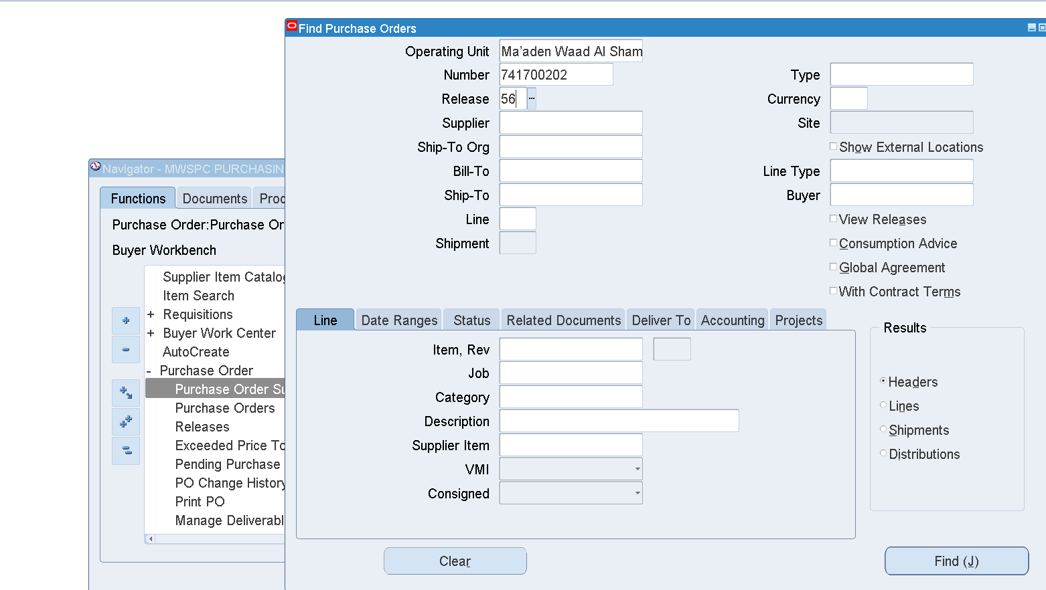

Inquire 🡪 Action History

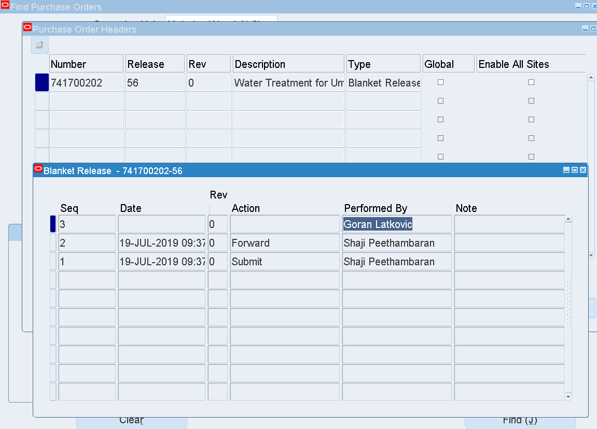

Login as Goran Latkovic to approve the Blanket Release

User – LATKOVICG

Select the Blanket Release worklist notification

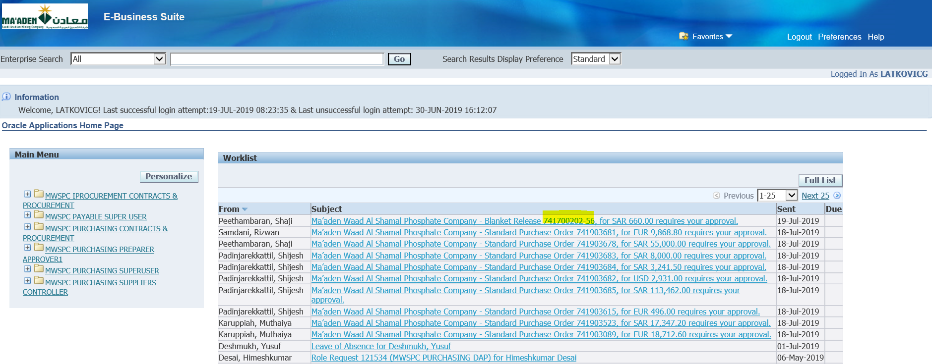

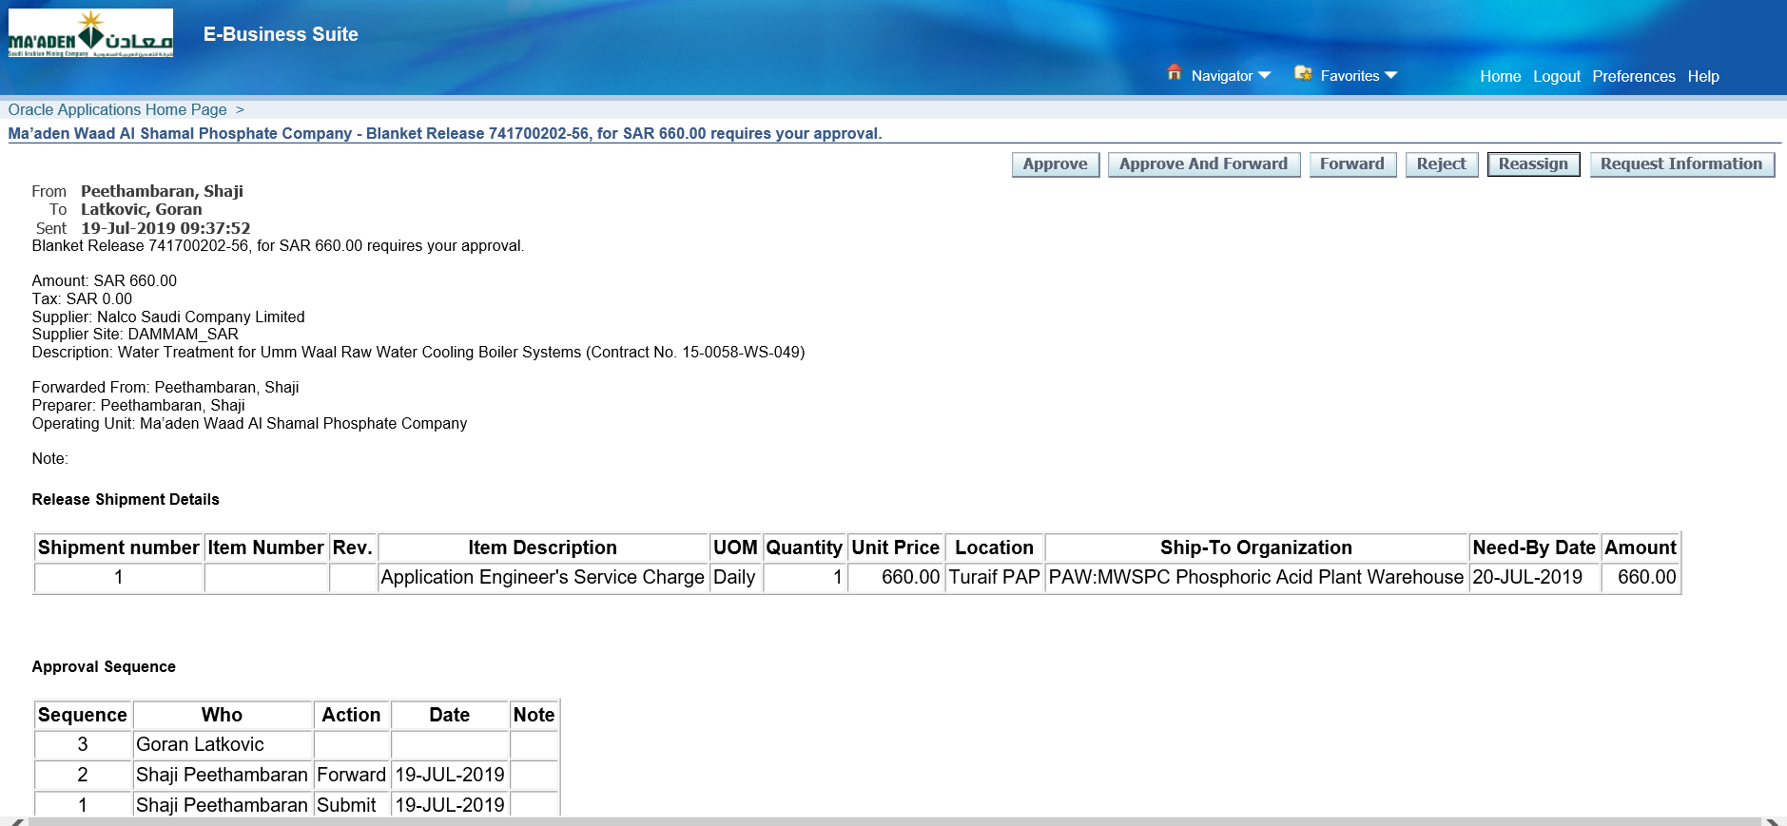

Approve

Check the Blanket Release Status

MWSPC Purchasing Super User 🡪 Purchase Order 🡪 Purchase order Summary

Enter the Blanket Release number as below

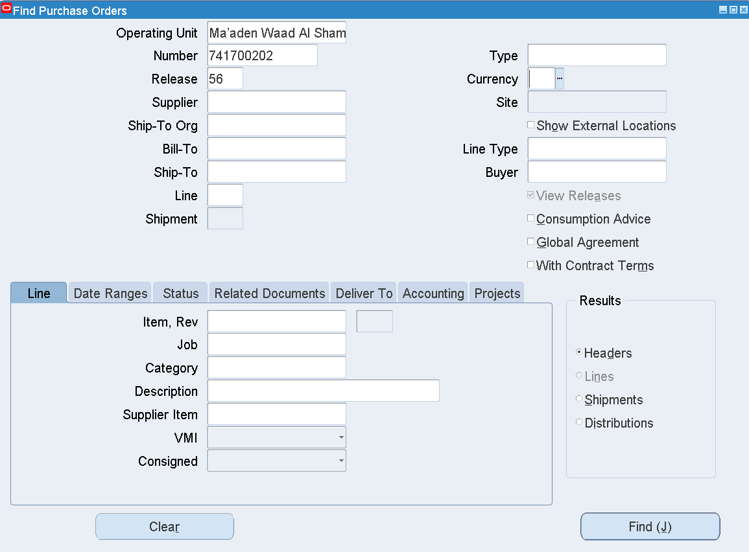

Find

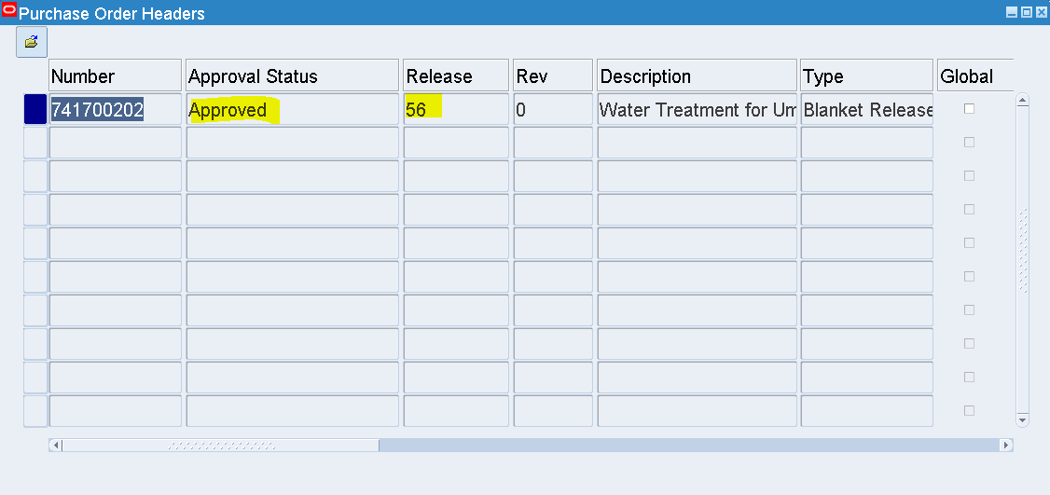

The Blanket Release has been Approved

1. Req creation 🡪 Req Approval 🡪 Standard PO creation from PR 🡪 PO Approval 🡪 PO Receipt creation

User – ABSIM

Responsibility – MIMC Purchasing Preparer

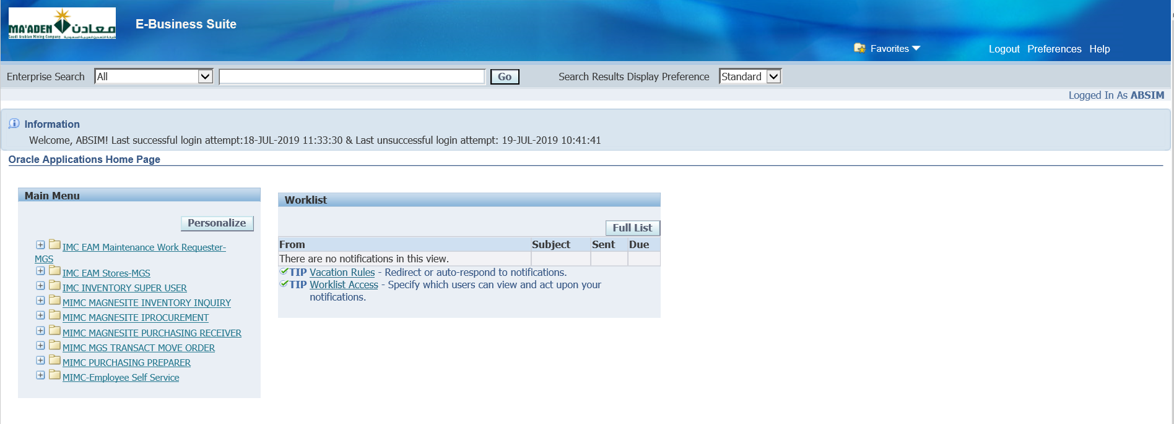

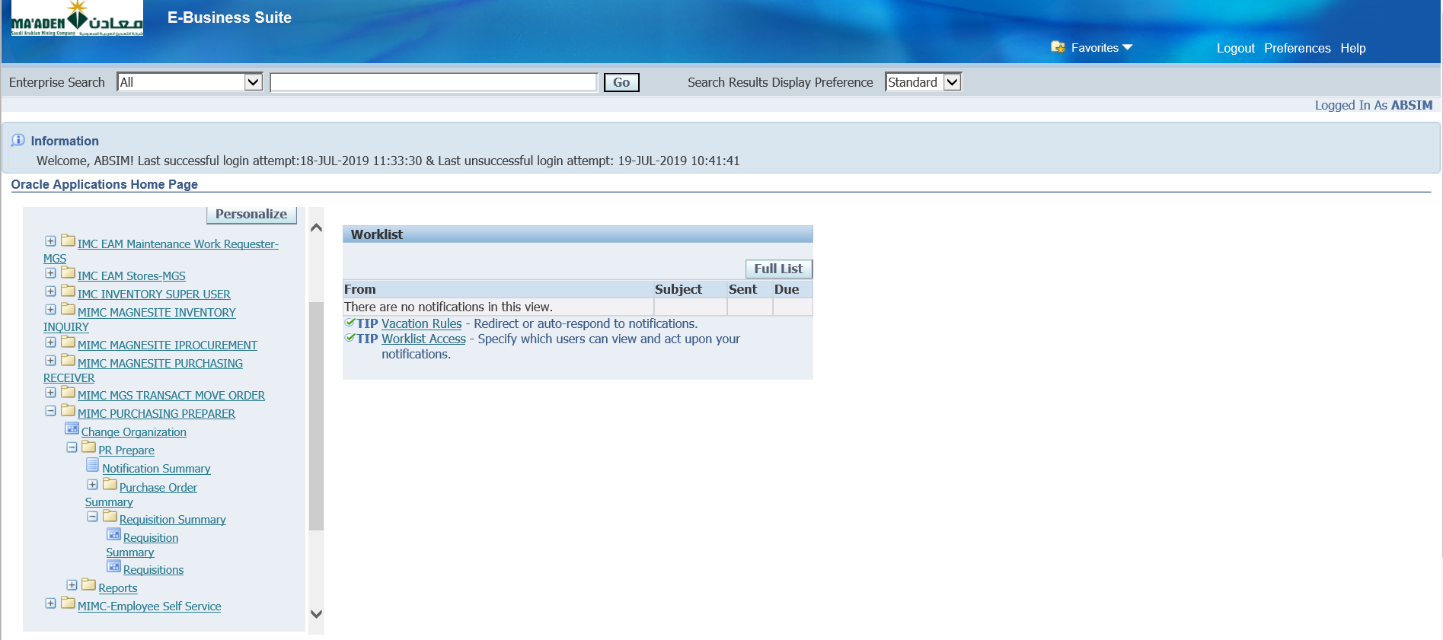

Requisition Summary 🡪 Requisitions

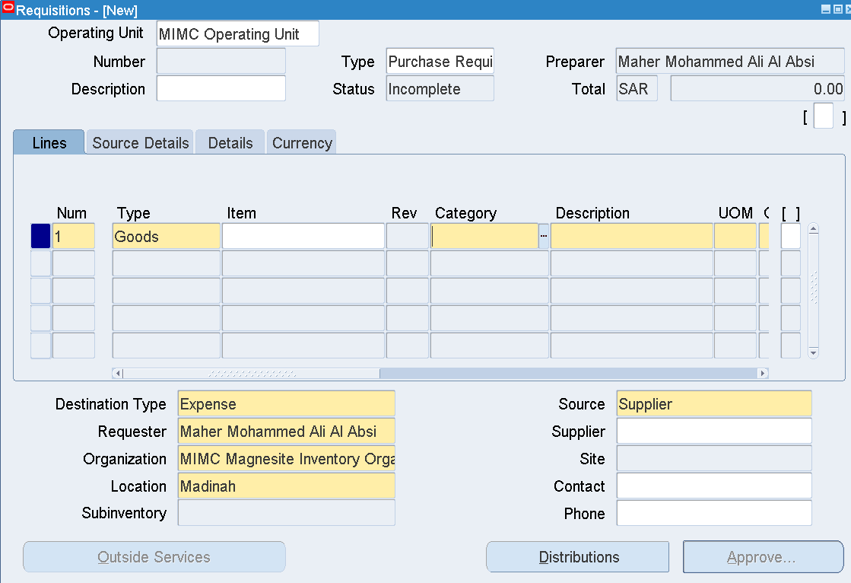

|  |  |
| --- | --- |
| Category | MISC.MISC |
| Description | CHEVROLET Silverado DC Base 1500 4doors 4x4 Automatic Petrol |
| UOM | Month |
| Quantity | 1 |
| Price | Enter some Price |
| Need by date | Any future date |
| Organization | MIMC Magnesite Inventory Organization |
| Location | Madinah |
| Supplier | AL TALA'A INTERNATIONAL TRANSPORTATION CO LTD. Hanco |
| Site | RIYADH |
| Source Details Tab |  |
| Document Type | Blanket Purchase Agreement |
| Document | 41803219 |
| Line | 1 |

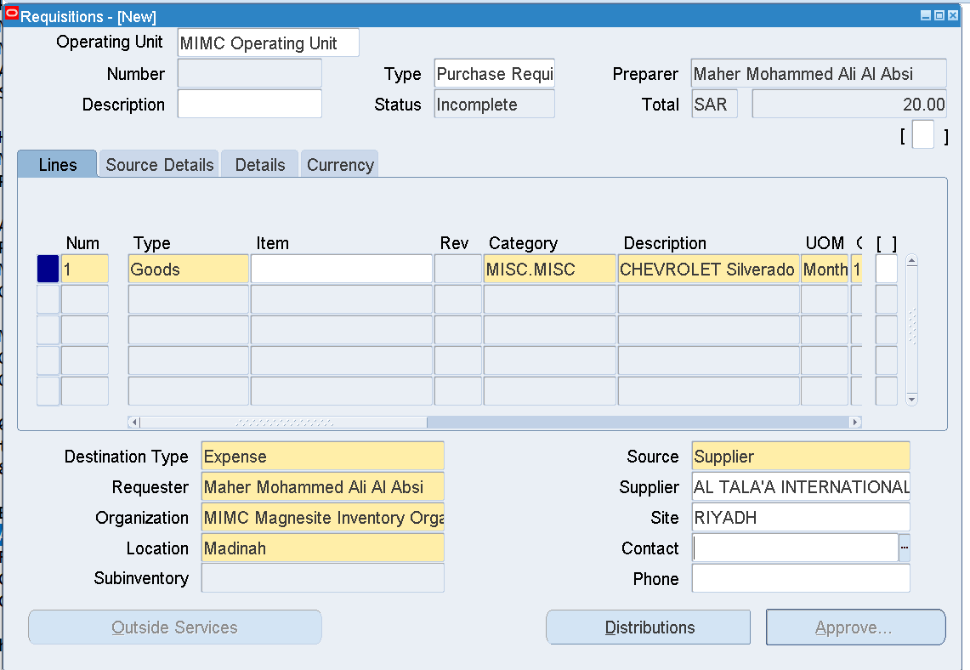

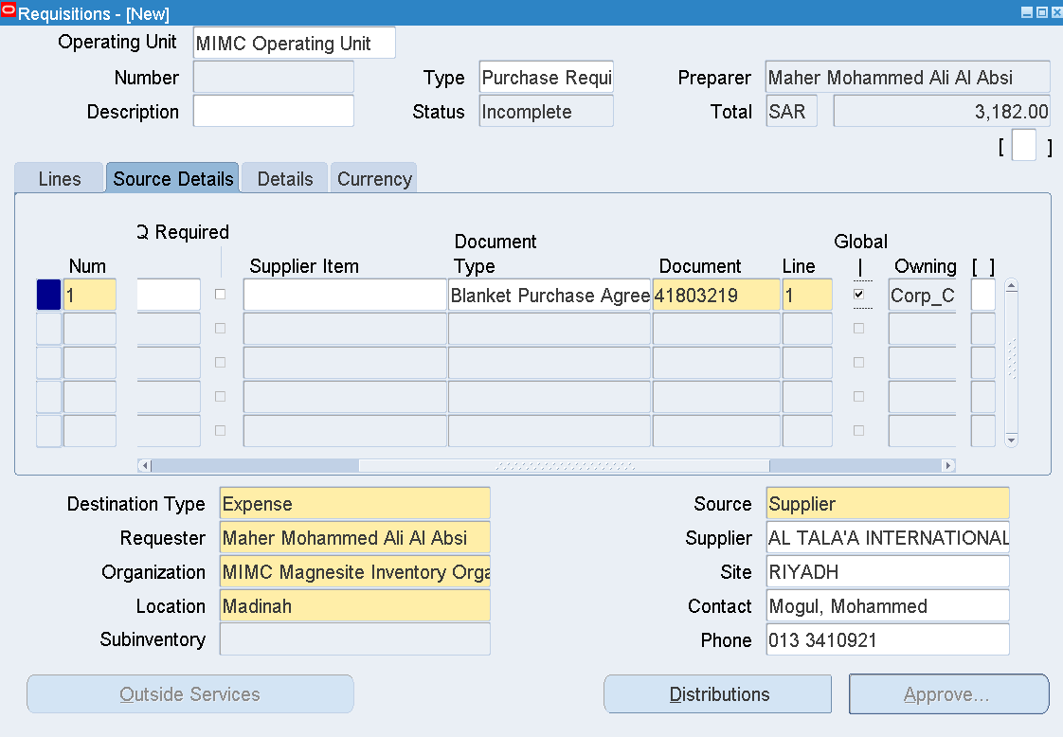

Distributions

Enter charge account - 01.03.300.11.6695.6365.00000

Save

Approve

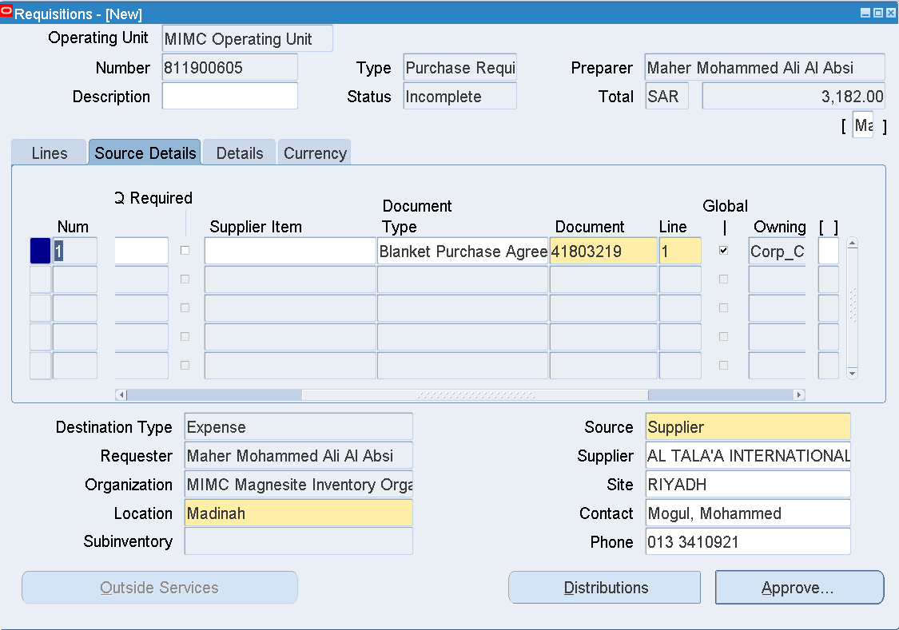

Requisition – 811900605

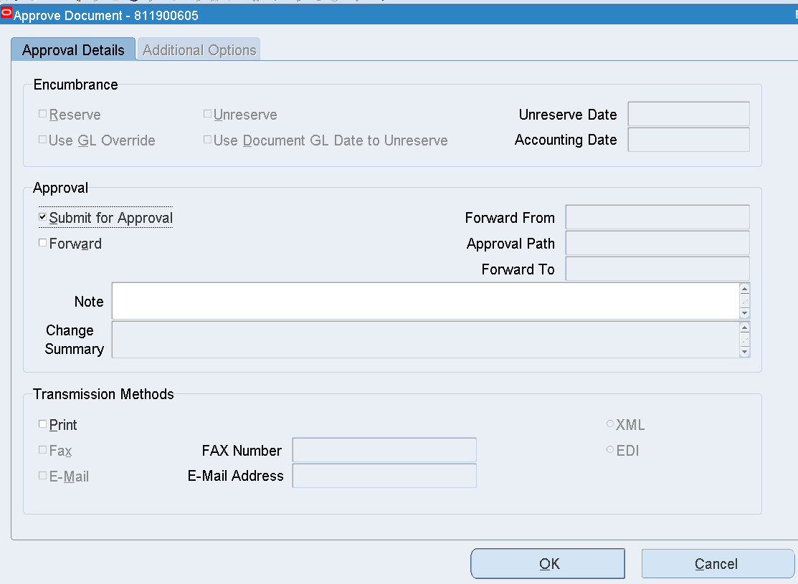

OK

Check the status of the Requisition

Requisition Summary 🡪 Requisition number 🡪 Find

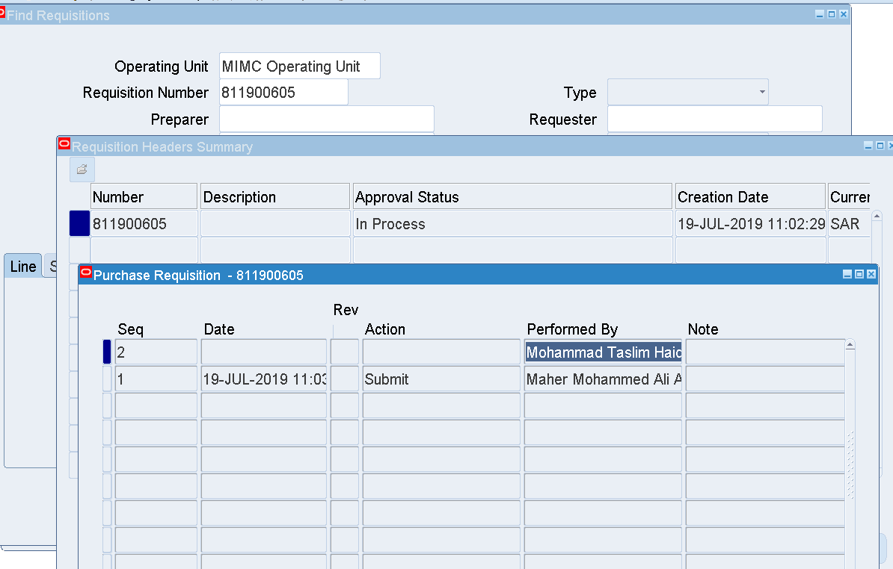

Tools 🡪 View Action History

It’s with Mohammad Taslim Haider for Approval

Login as HAIDER

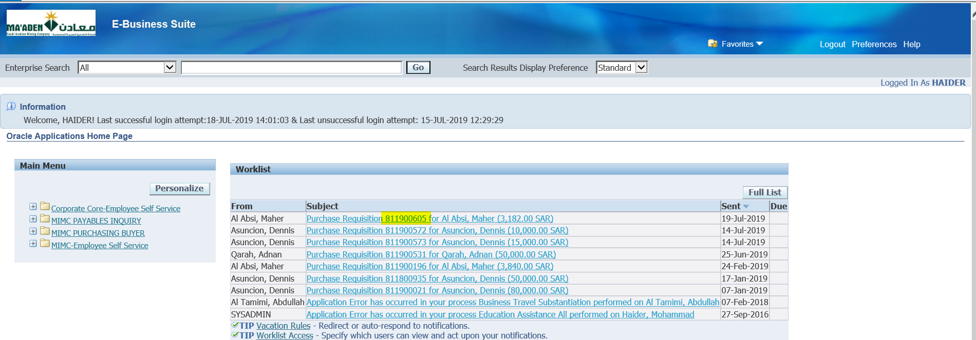

Select the Requisition

Approve

Then Login as DIABS to approve again

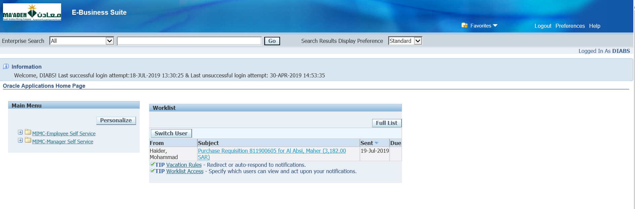

Select the Requisition

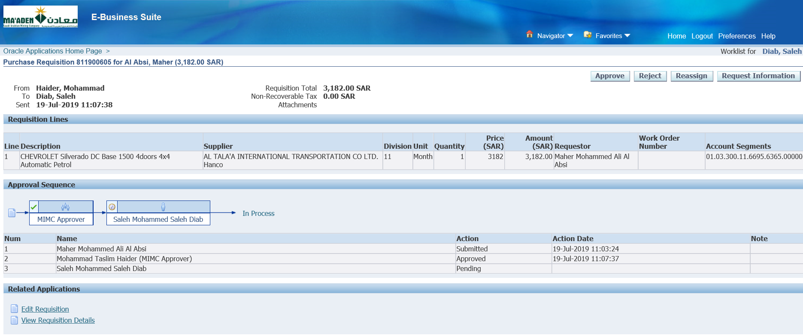

Approve

Login as FAREEDM

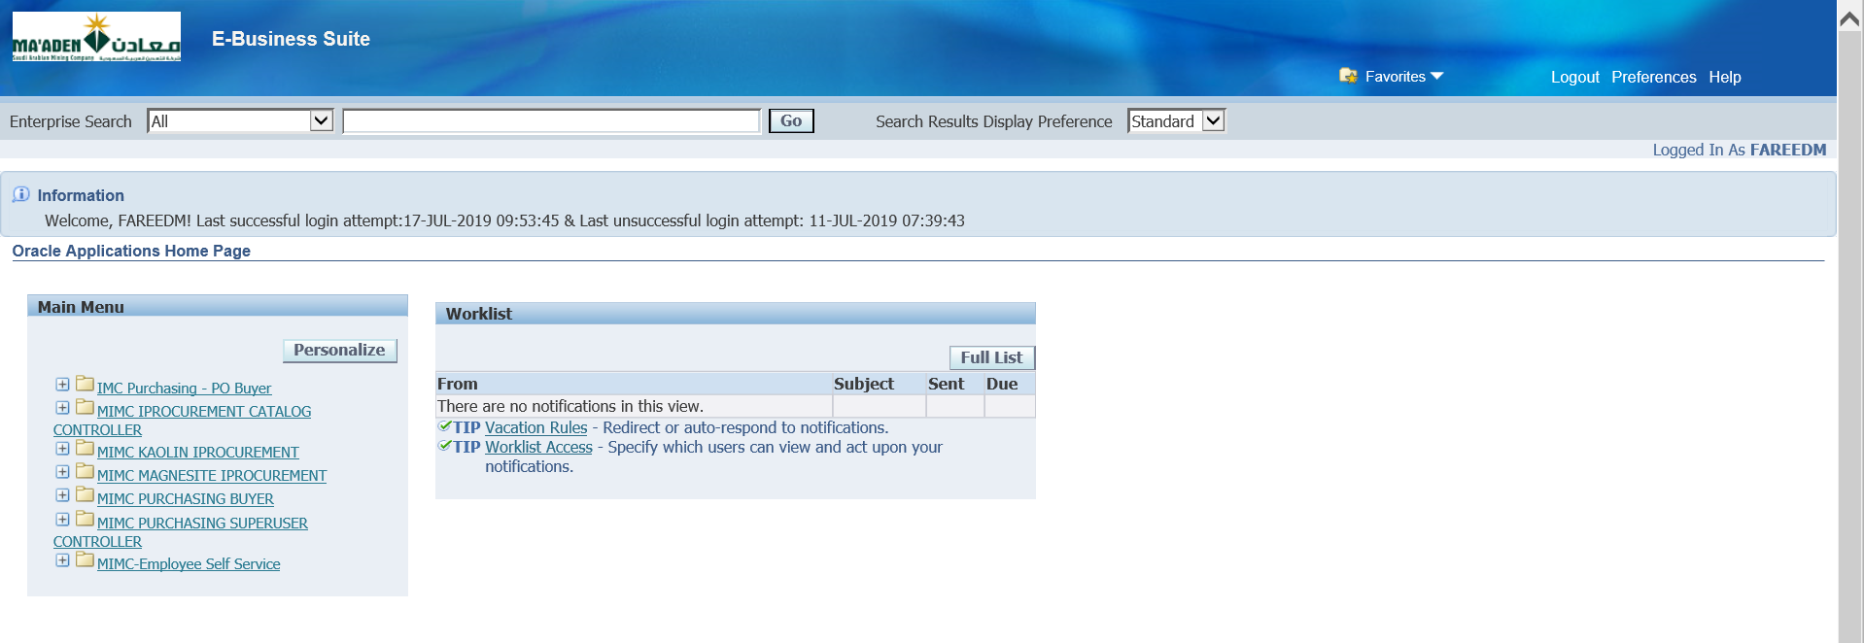

Responsibility 🡪 MIMC Purchasing Buyer🡪 Autocreate

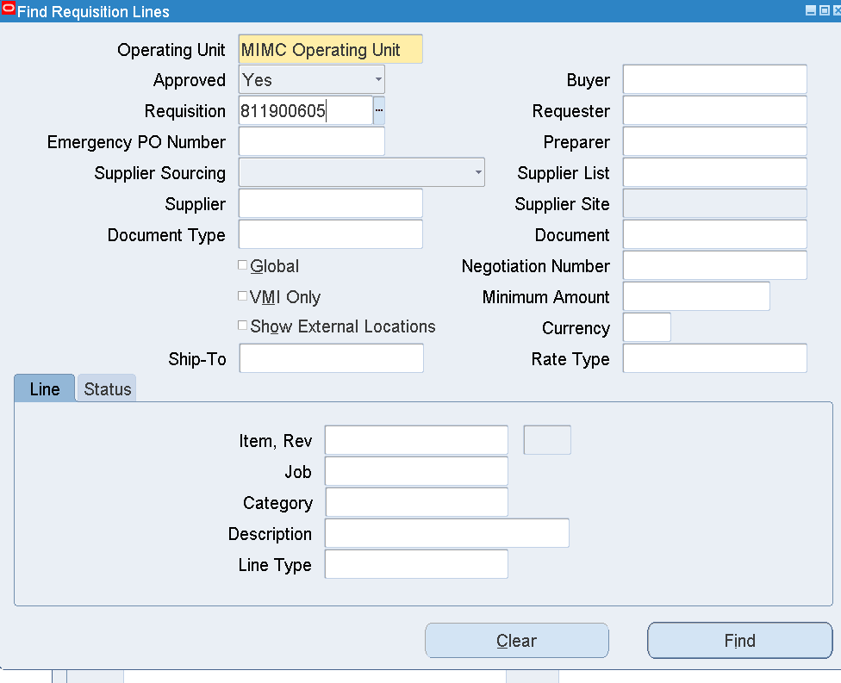

Clear Buyer Name

Enter Requisition number

Find

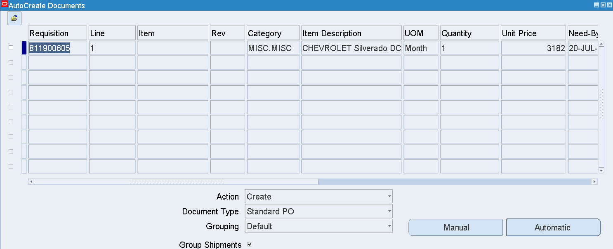

Select the Requisition Line 🡪 Automatic

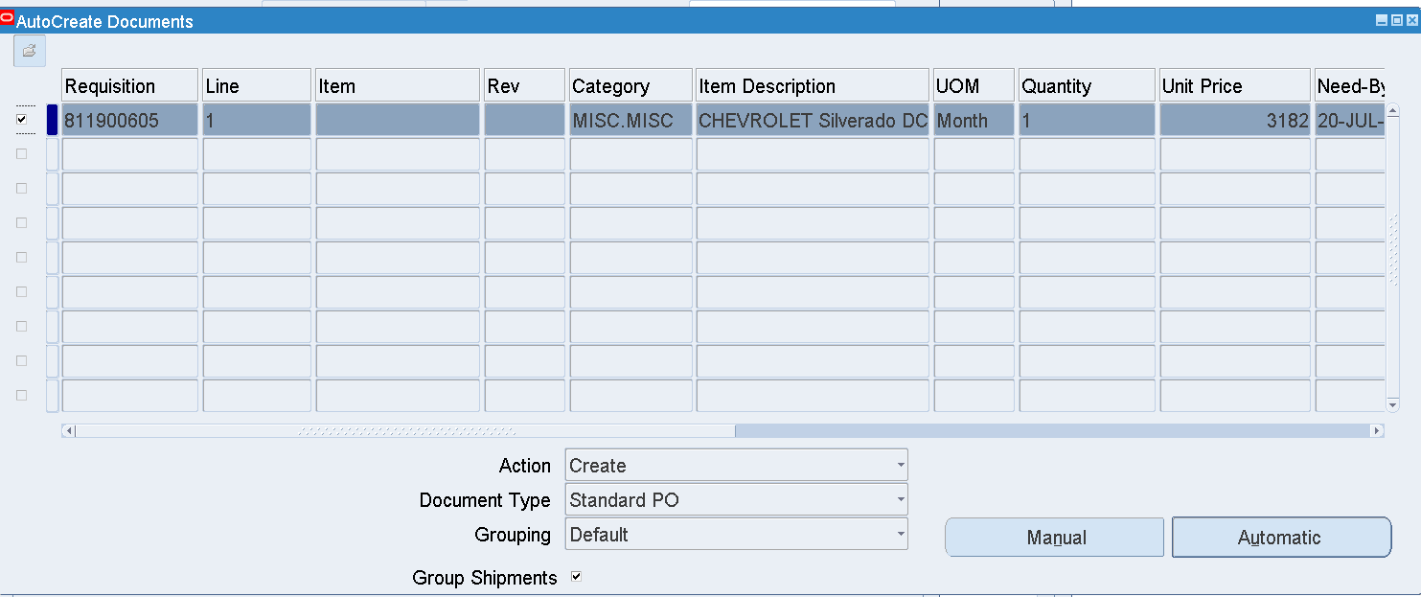

Automatic

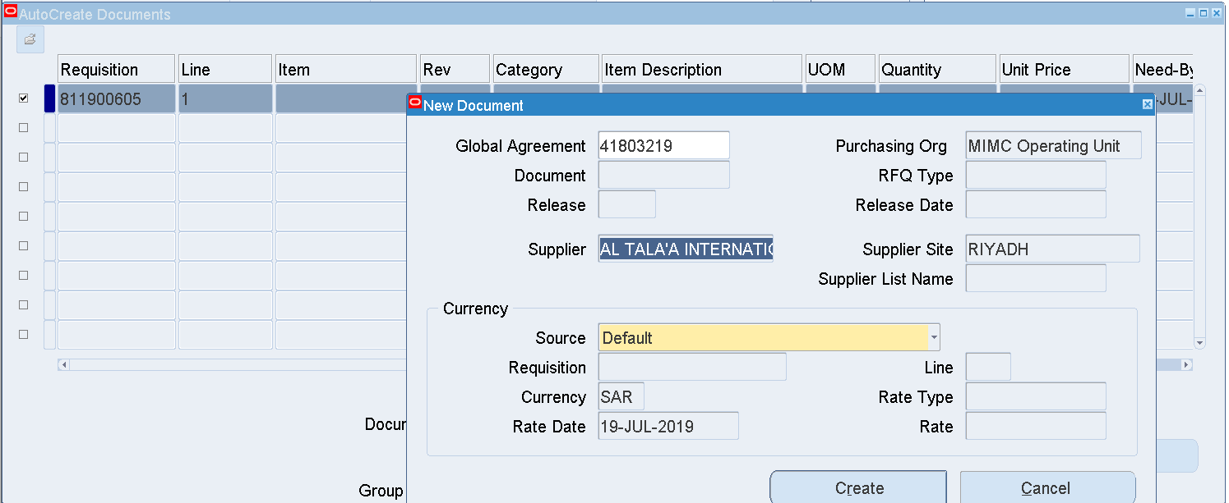

Create

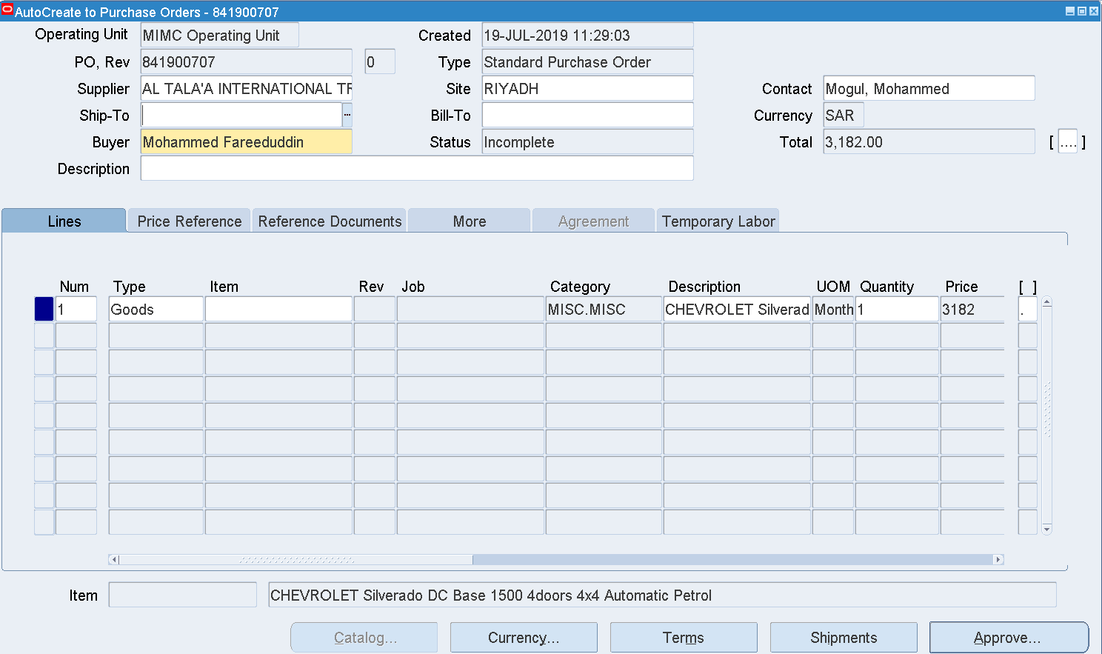

PO-841900707

Terms

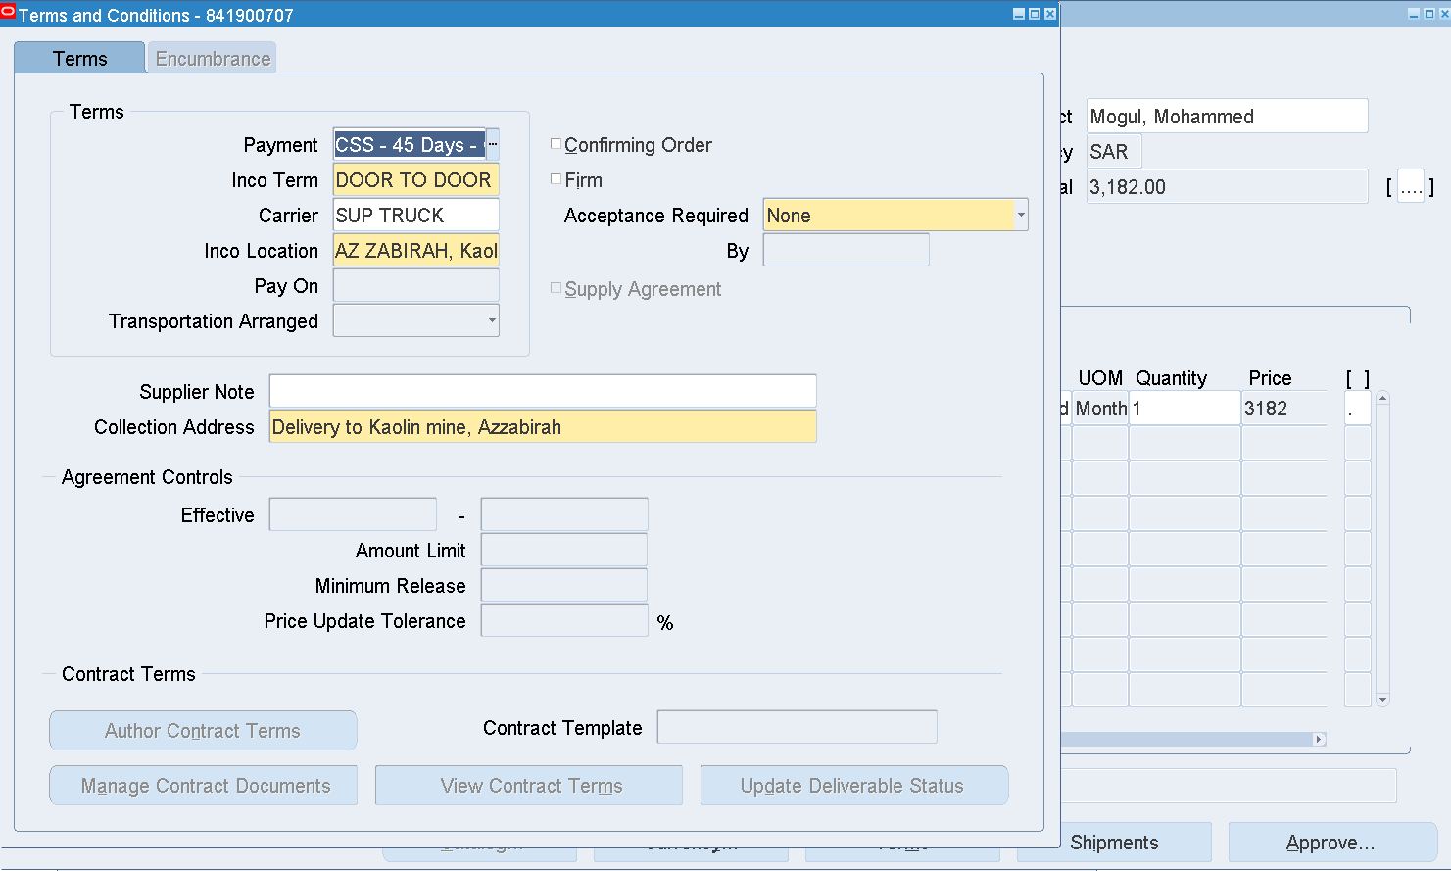

|  |  |
| --- | --- |
| Inco Term | DOOR TO DOOR |
| Carrier | SUP TRUCK |
| Inco Location | AZ ZABIRAH, Kaolin Project |
| Collection Address | Delivery to Kaolin mine, Azzabirah |

Enter Ship to and Bill to as below

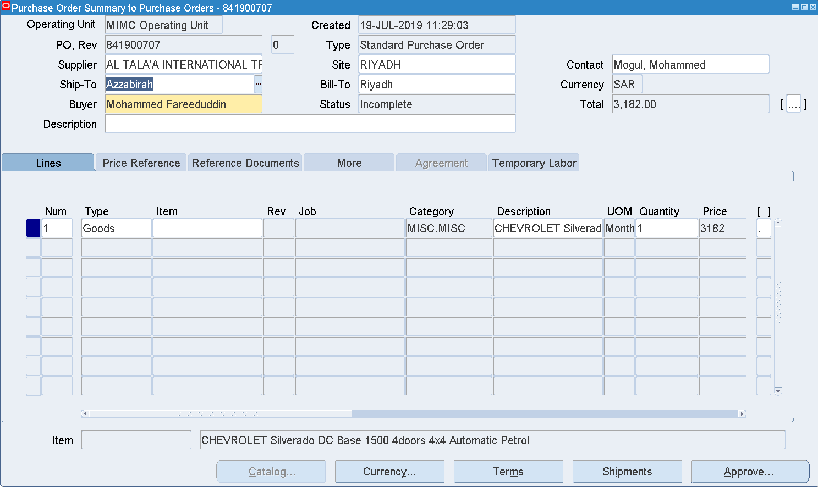

Header DFF

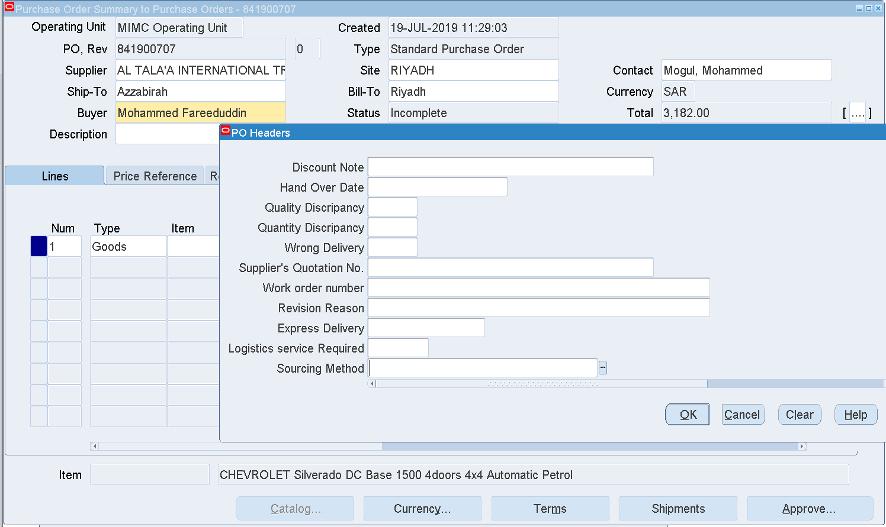

Sourcing Method

Enter – Single Source

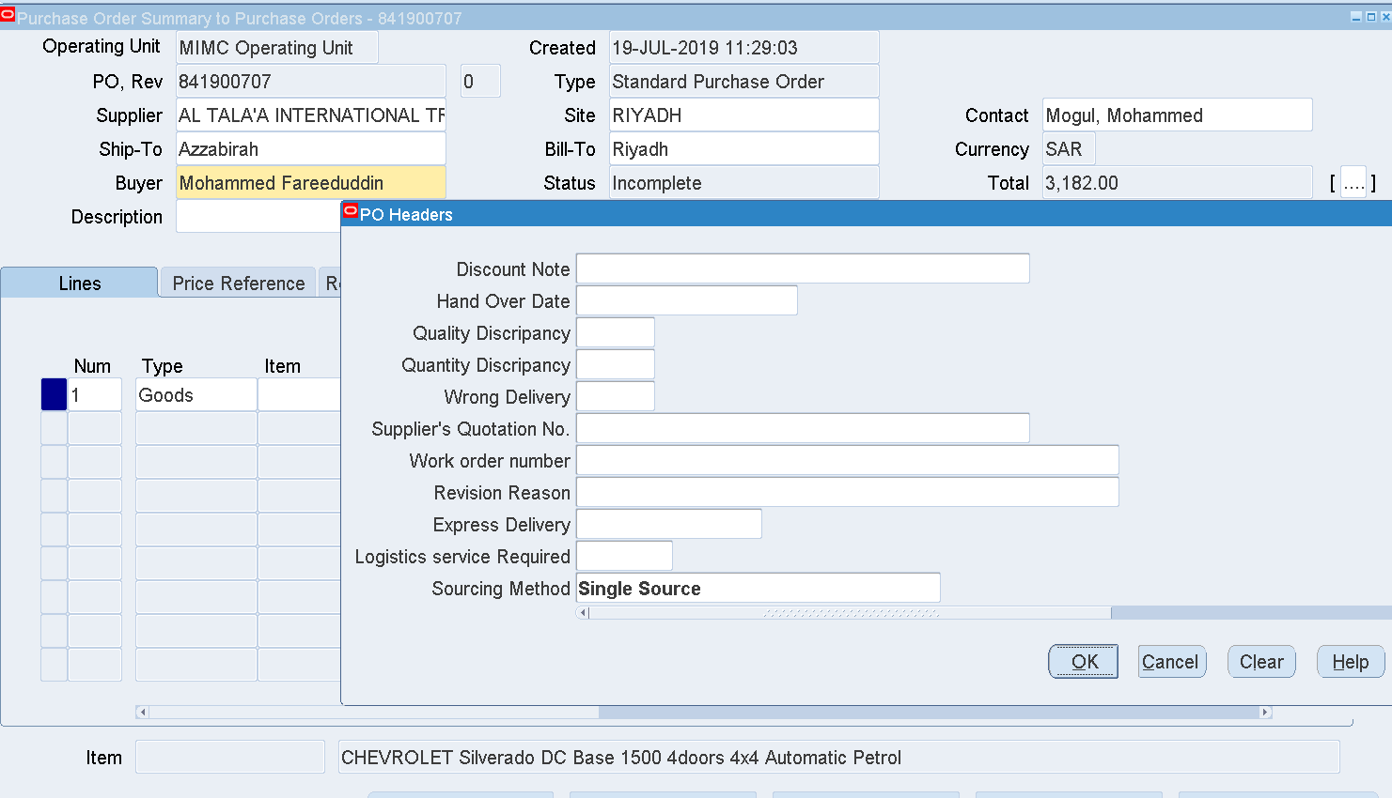

OK

Approve

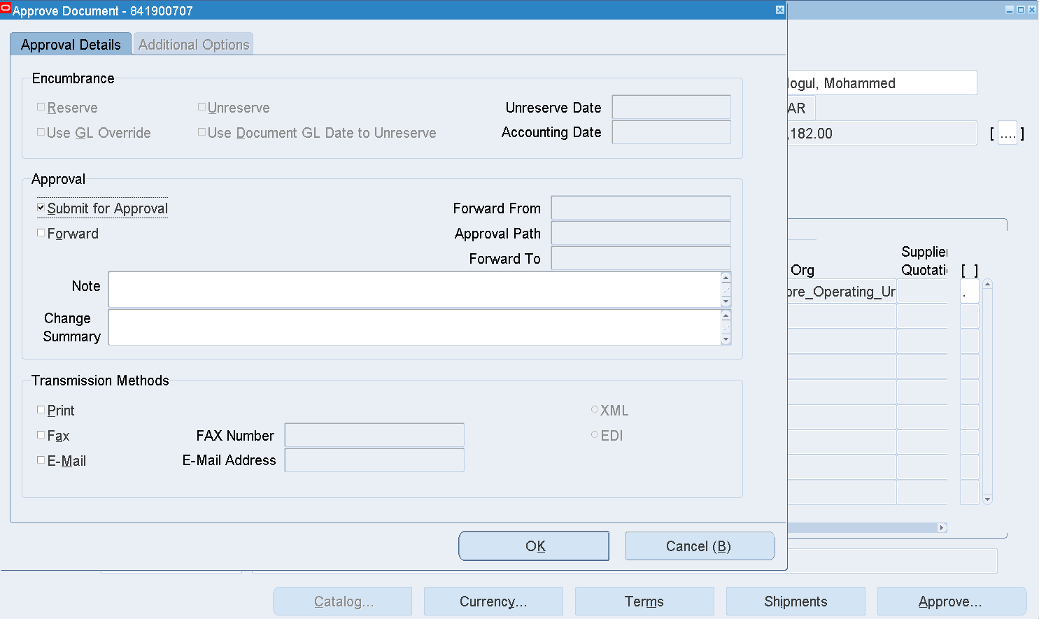

OK

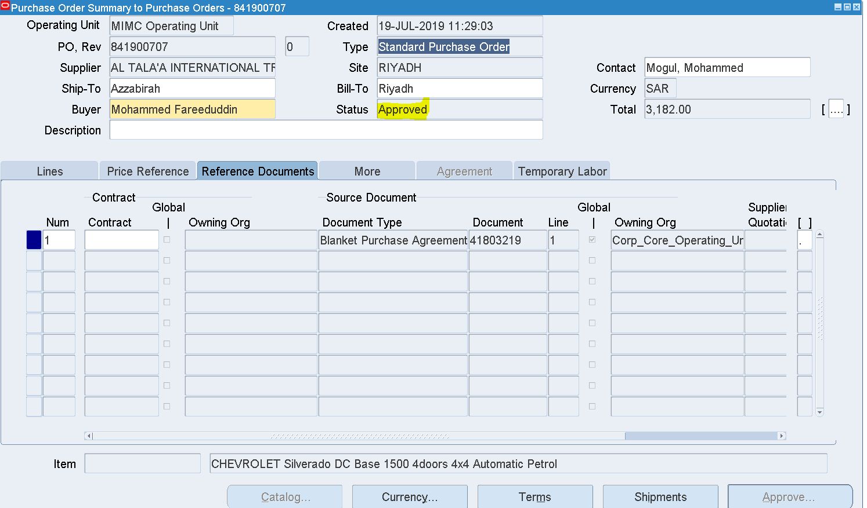

The PO 841900707 has been Approved

Receipts 🡪Receipts

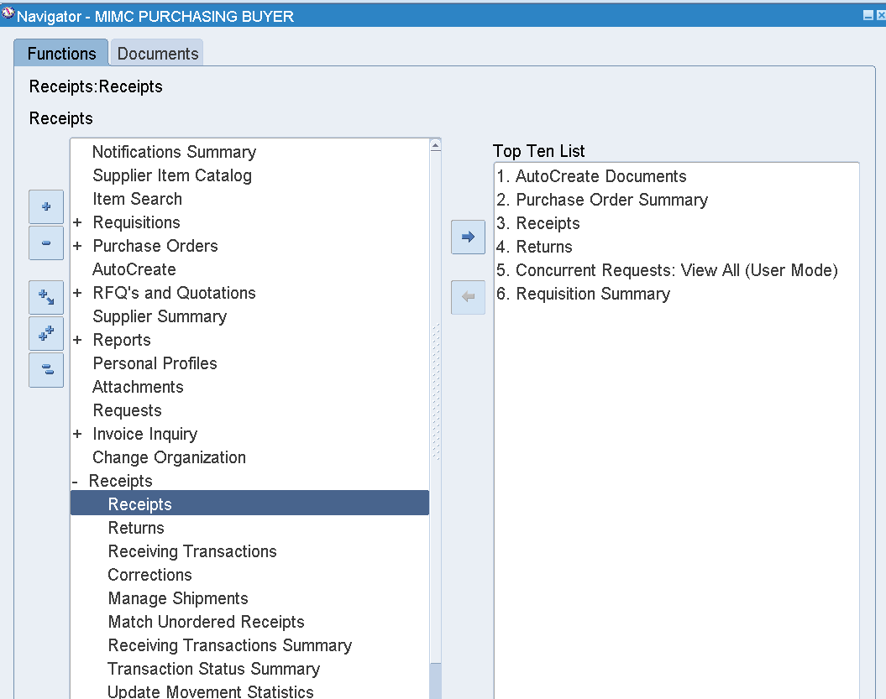

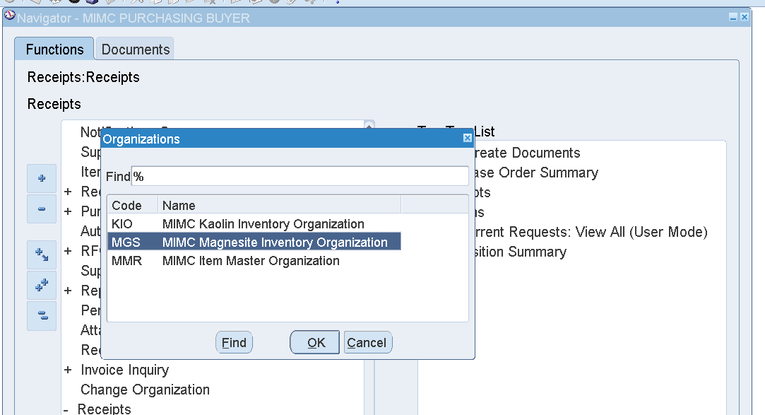

Select the Org – MGS

OK

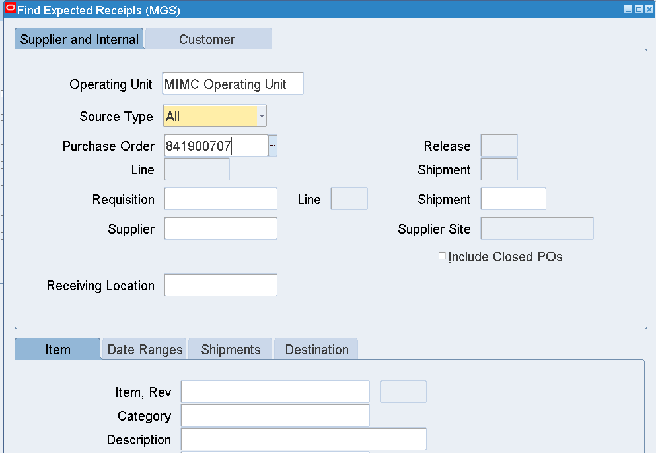

Enter Purchase Order Number

Find

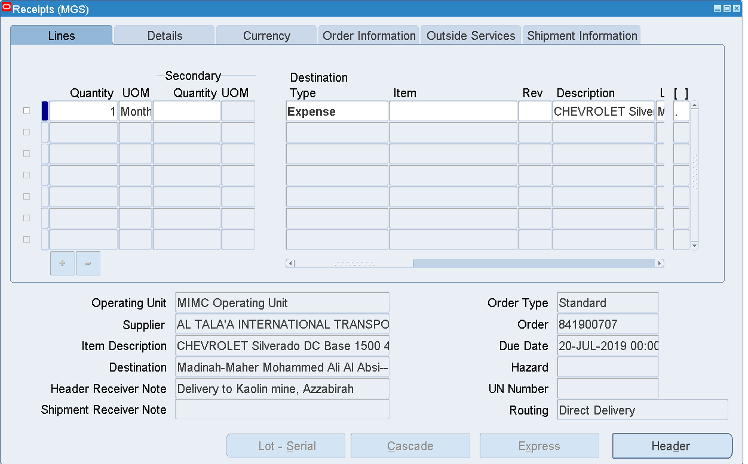

Select the Line

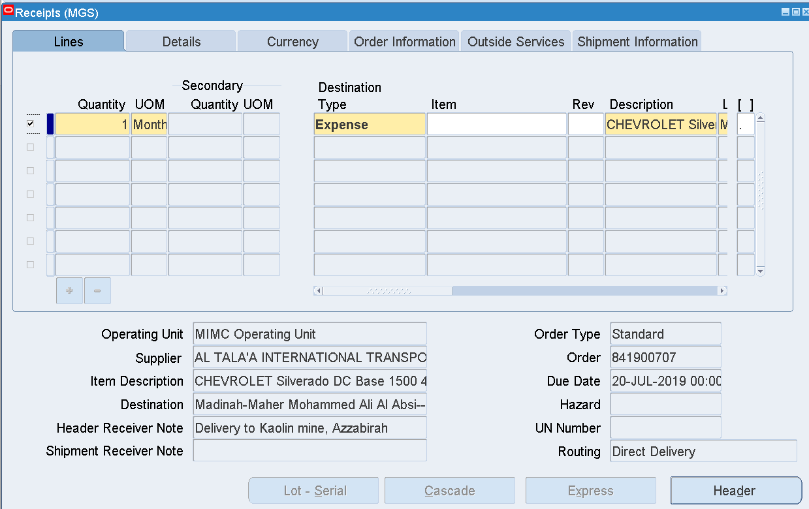

Save

Click the Header

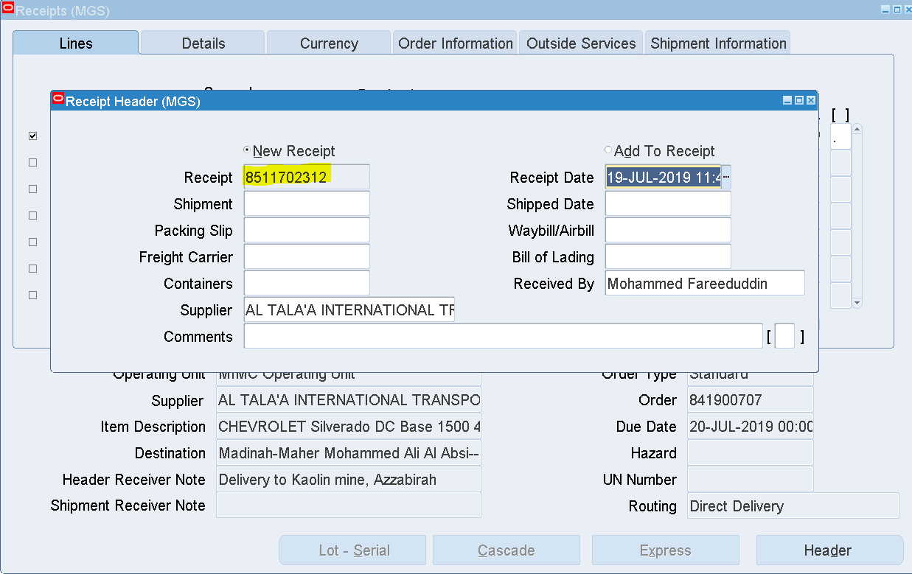

Receipt 8511702312 has been generated

1. PO creation 🡪 PO Approval 🡪 Receipt creation 🡪 Invoice creation

Login as HINOH

Responsibility 🡪 CORP Purchasing PO Buyer

Purchase Orders 🡪 Purchase Orders

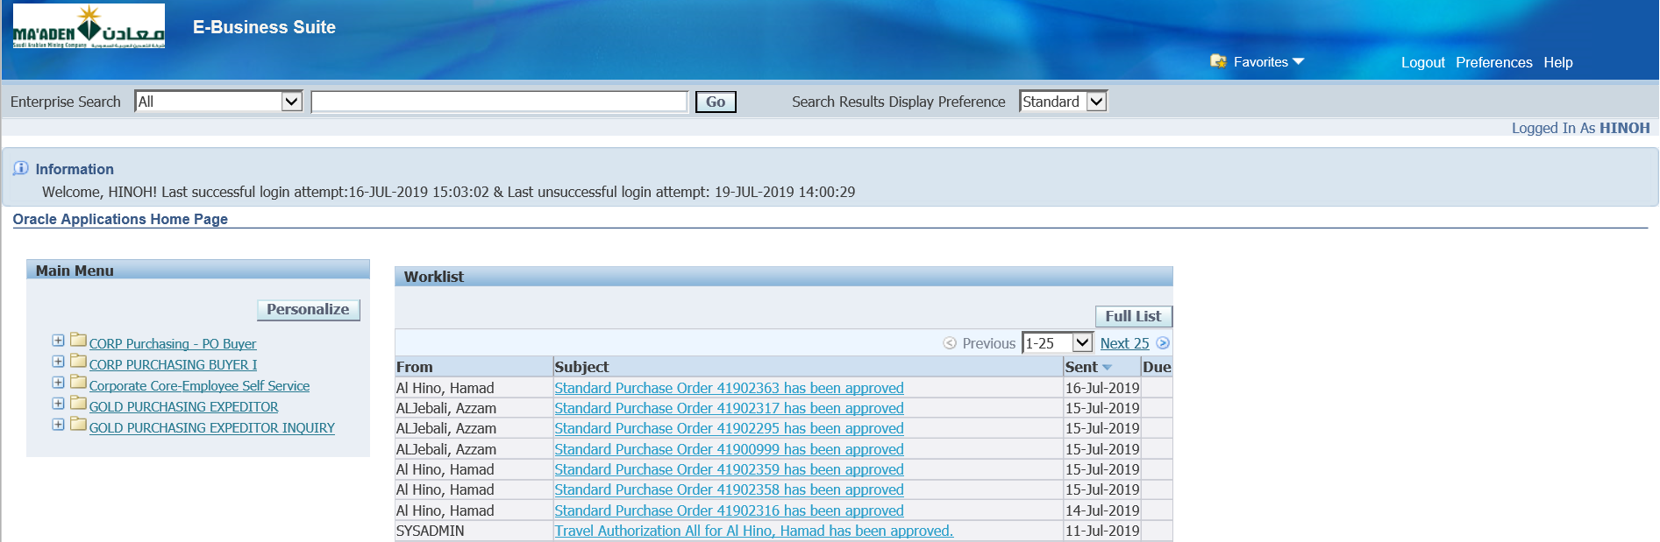

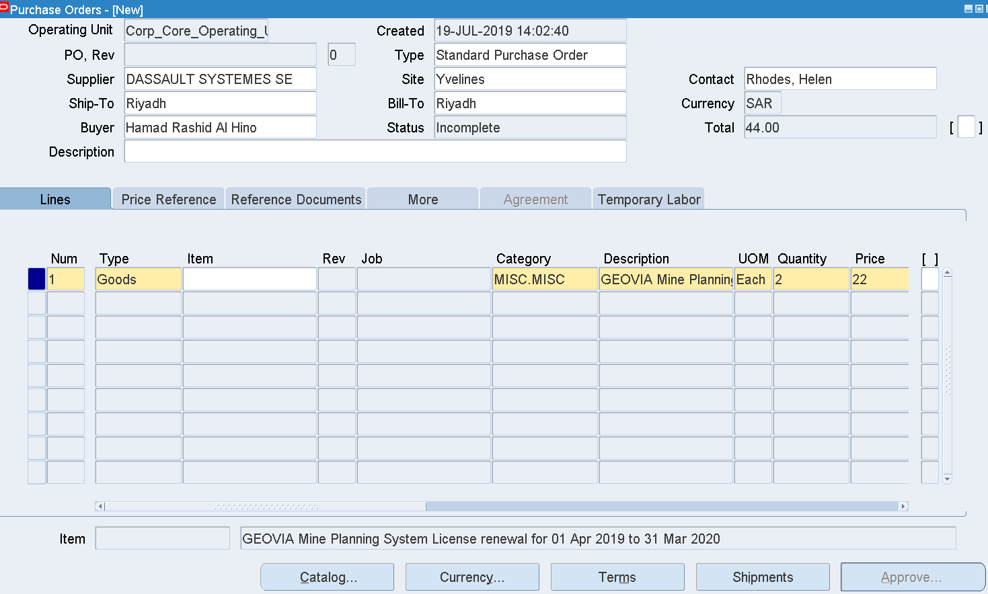

|  |  |
| --- | --- |
| Supplier | DASSAULT SYSTEMES SE |
| Site | Yvelines |
| Contact | Rhodes, Helen |
| Category | MISC.MISC |
| Description | GEOVIA Mine Planning System License renewal for 01 Apr 2019 to 31 Mar 2020 |
| Quantity | Enter some qty |
| Price | Price |
| Promised Date | Enter future date |
| Need by date | Enter future date |
|  |  |
|  |  |
|  |  |
|  |  |
| **Shipments** |  |
| Ship to Org | CIN |
| Location | Riyadh |
| Charge Account in Distributions | 01.01.100.74.9900.6364.30403 |

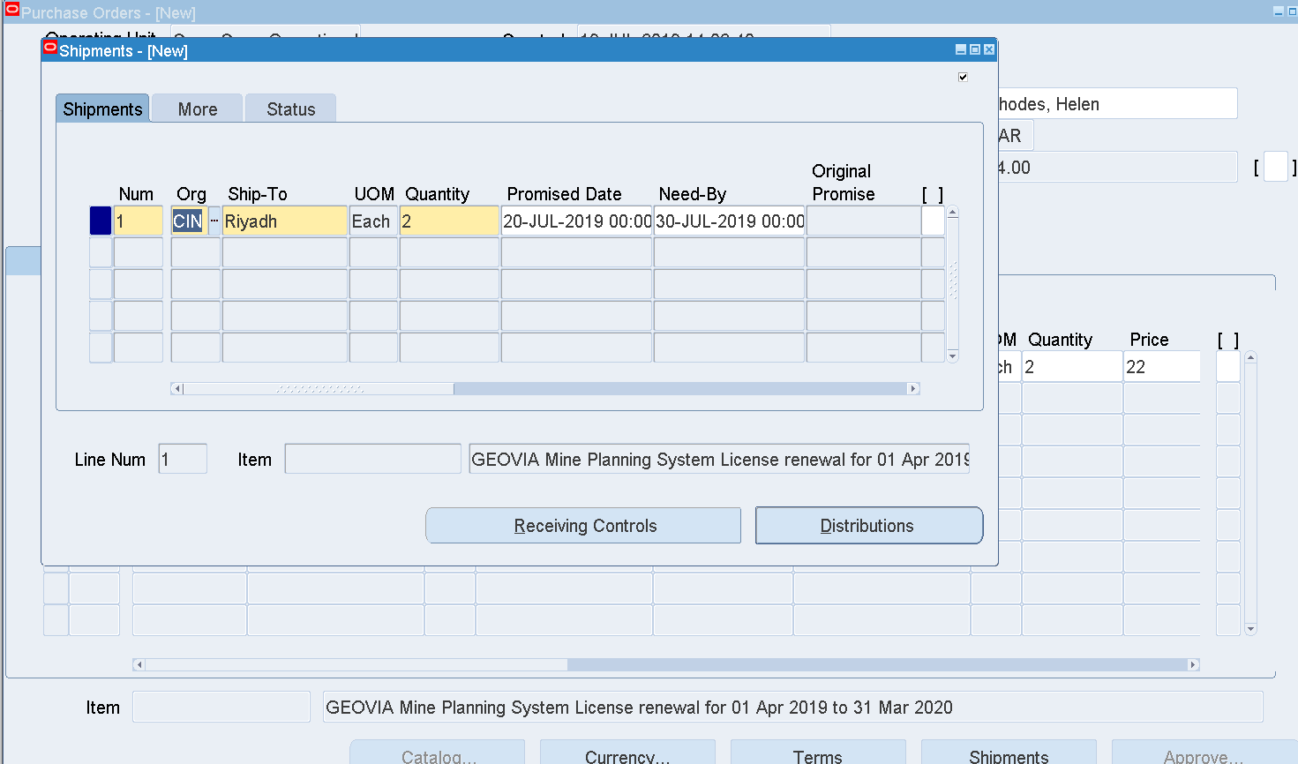

Distributions🡪 Charge Account 🡪 01.01.100.74.9900.6364.30403

PO Header – DFF

Source – Single Source

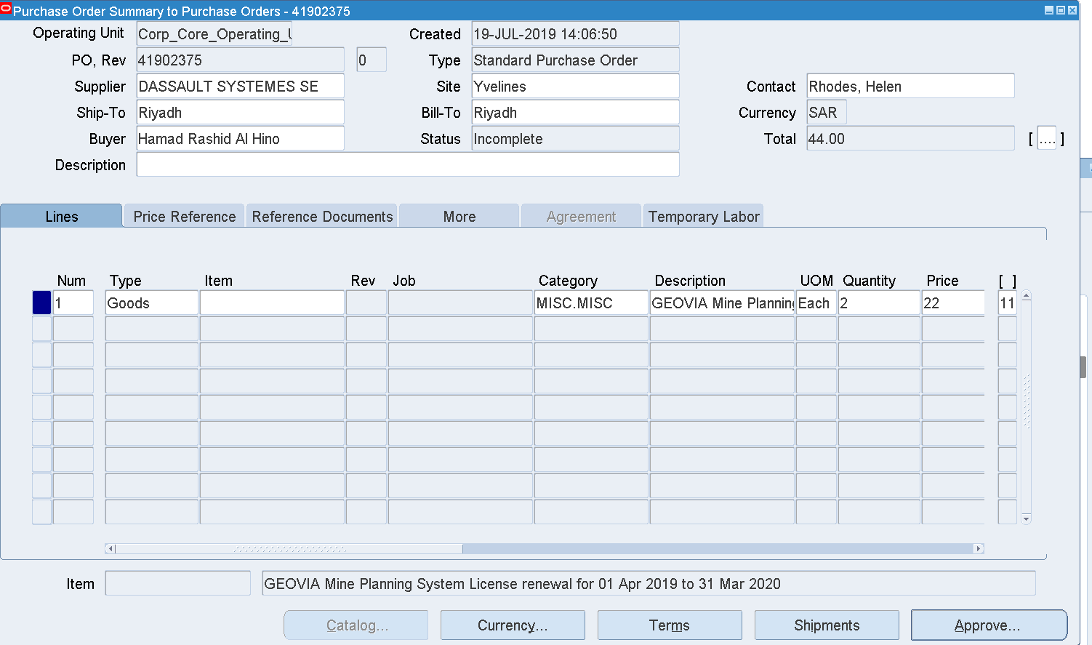

OK

Save

Approve

PO -41902375

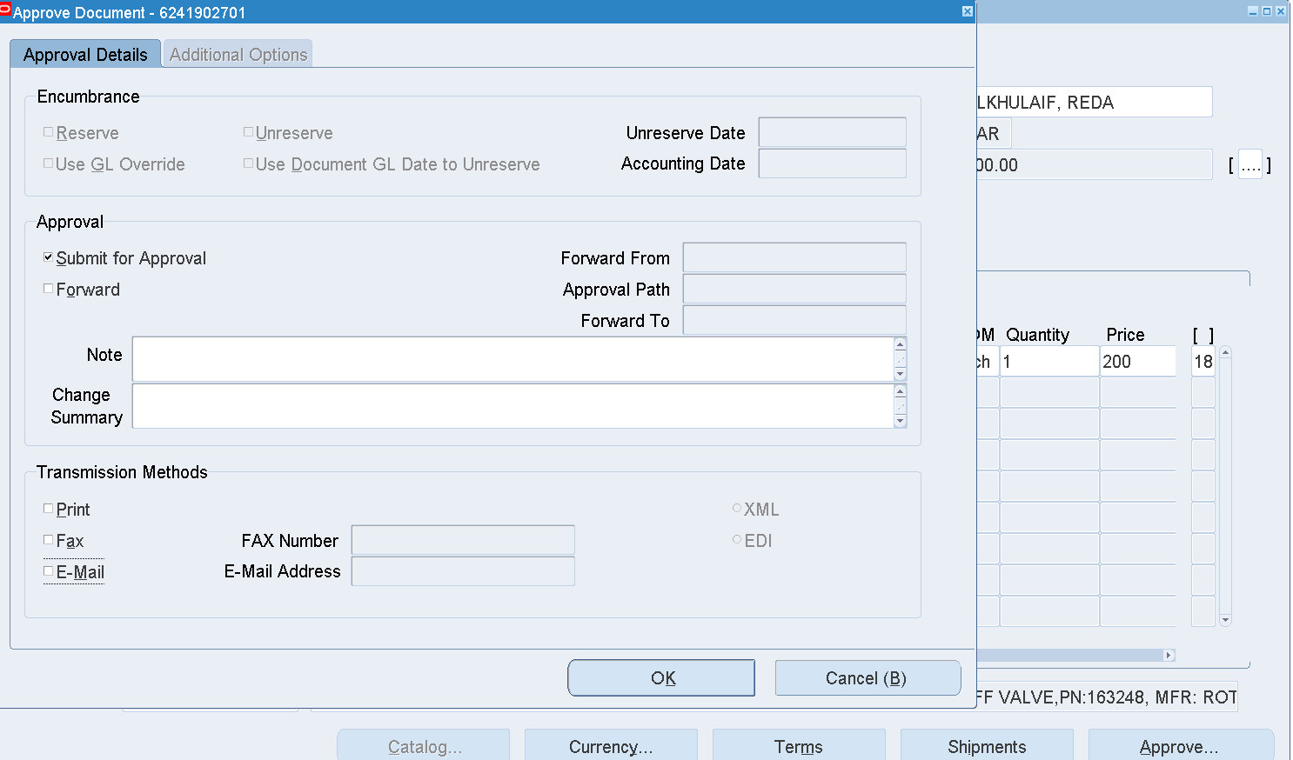

OK

PO has been Approved

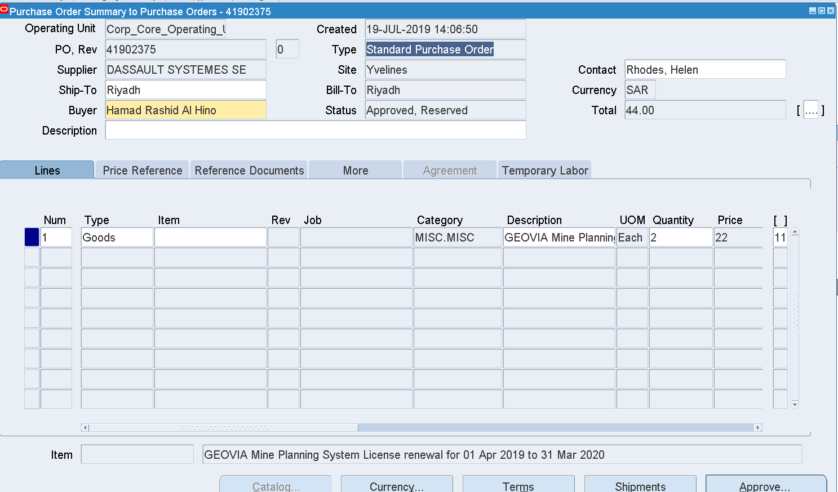

Create a Receipt

Responsibility 🡪 CORP Purchasing Buyer

Receipts 🡪 Receipts

Enter PO Number 🡪 Find

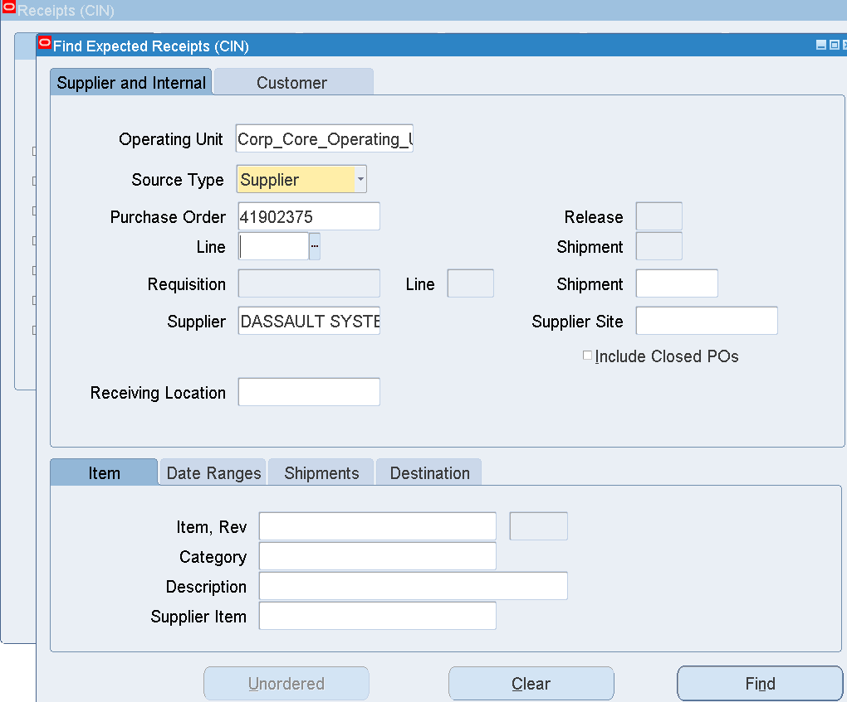

Find

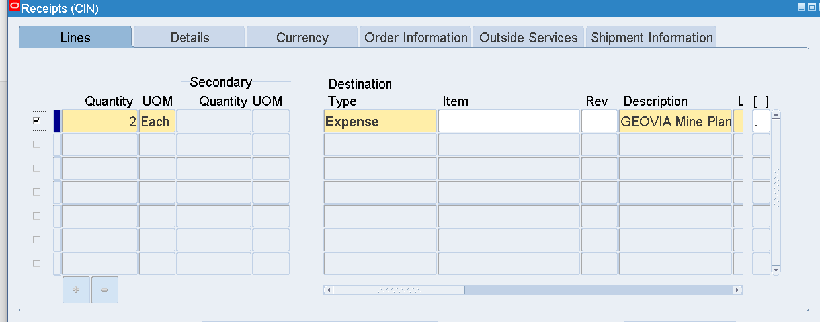

Select the Line

Enter Location - Riyadh

Save

Click Header

Receipt – 51901453

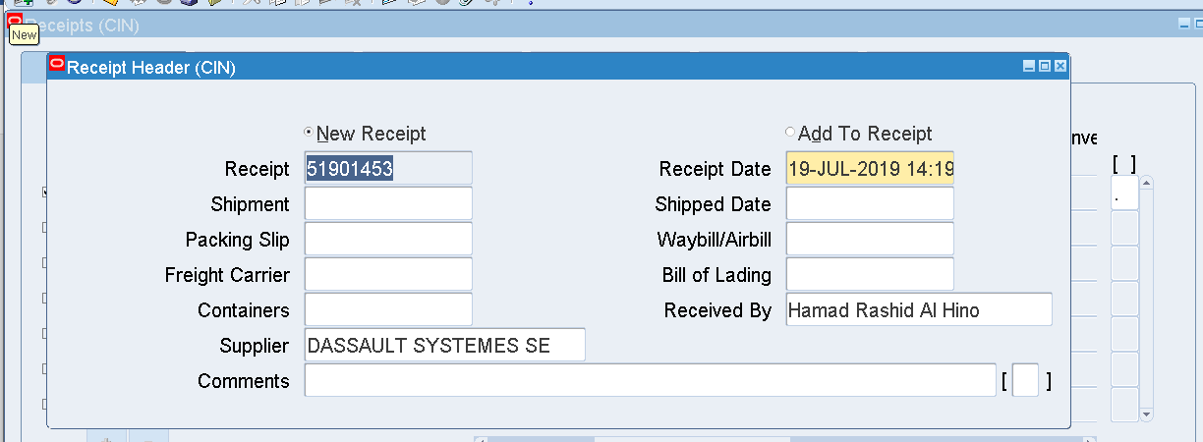

Create an Invoice

Login as [Helen.RHODES@3ds.com](mailto:Helen.RHODES@3ds.com)

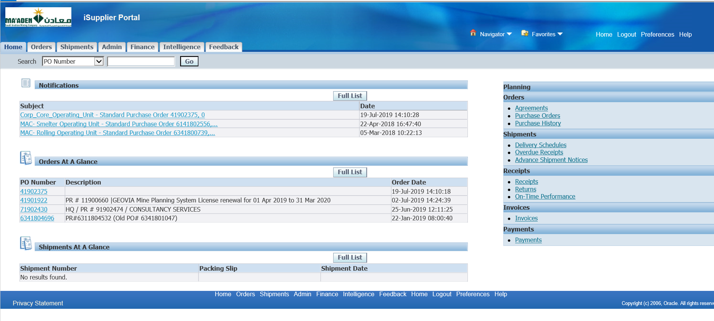

Finance tab

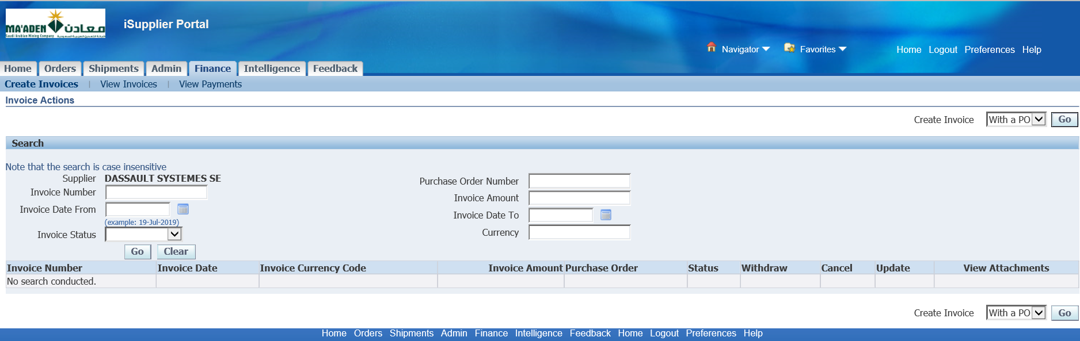

Create Invoice with a PO

Go

PO – 41902375

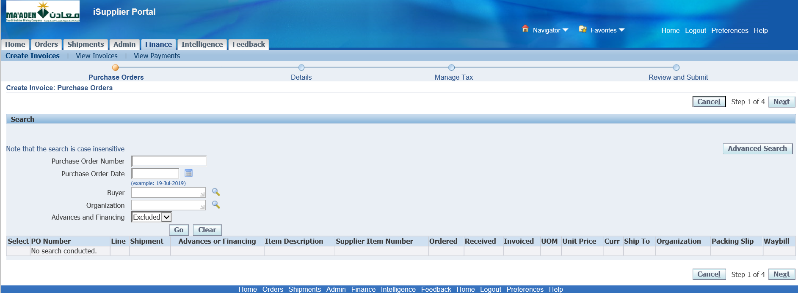

Enter PO number and Click Go

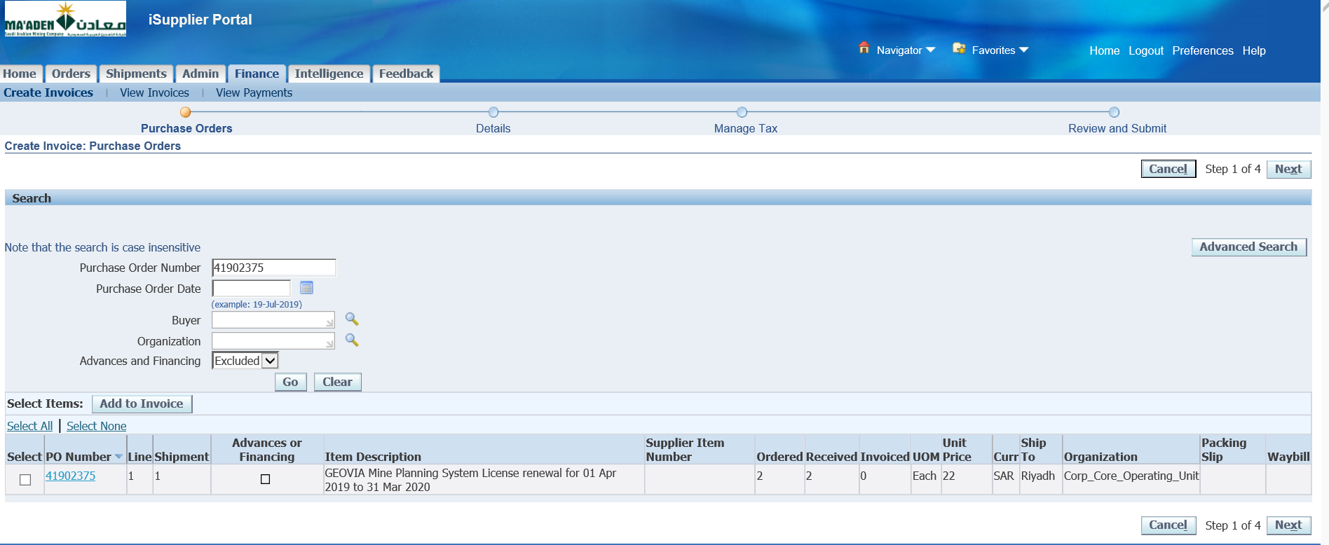

Select the Line 🡪 Add to Invoice

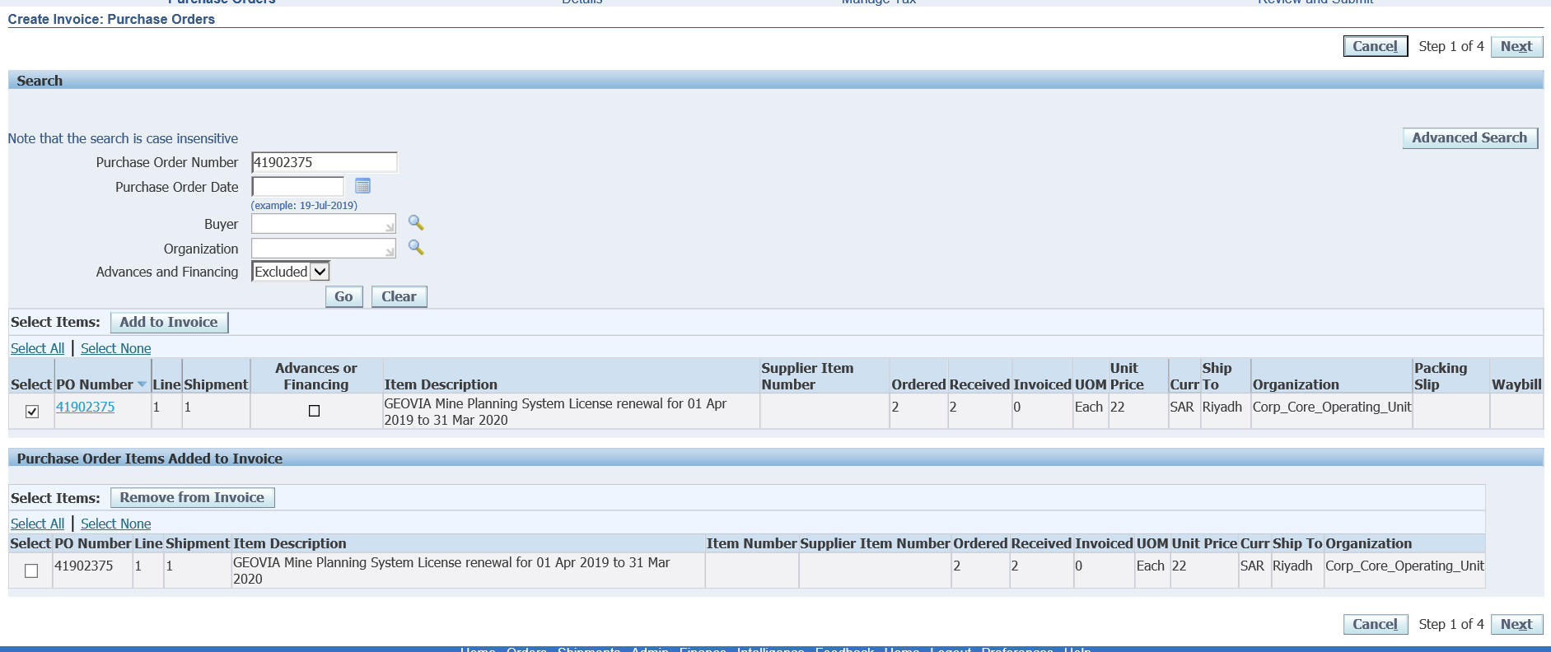

Click Next

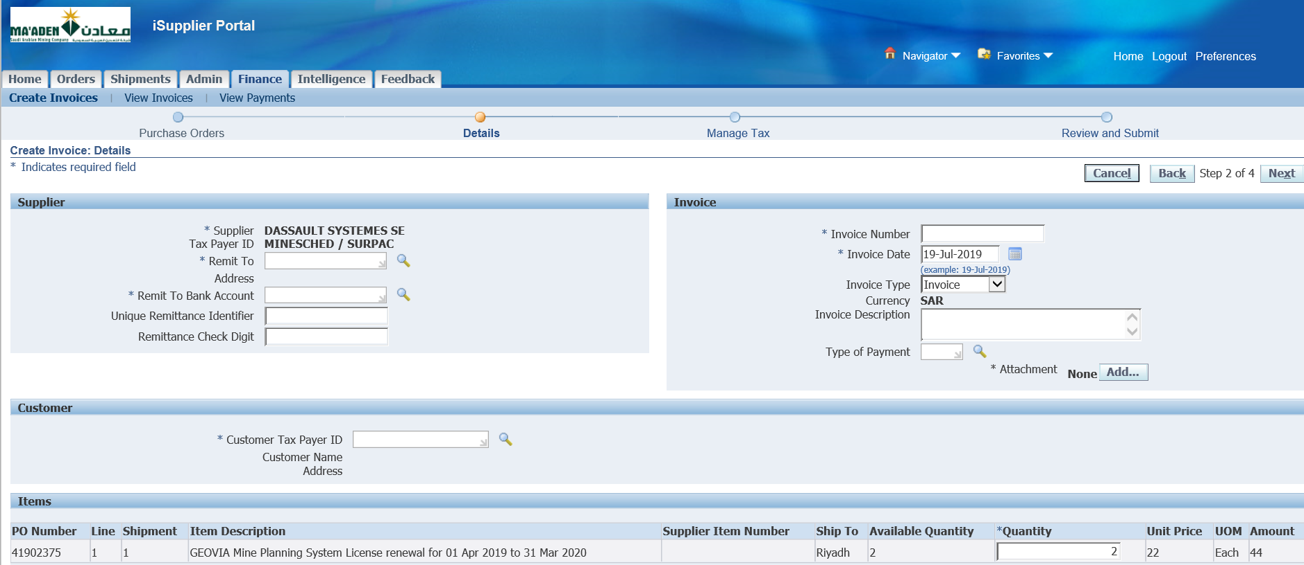

Search for Remit to

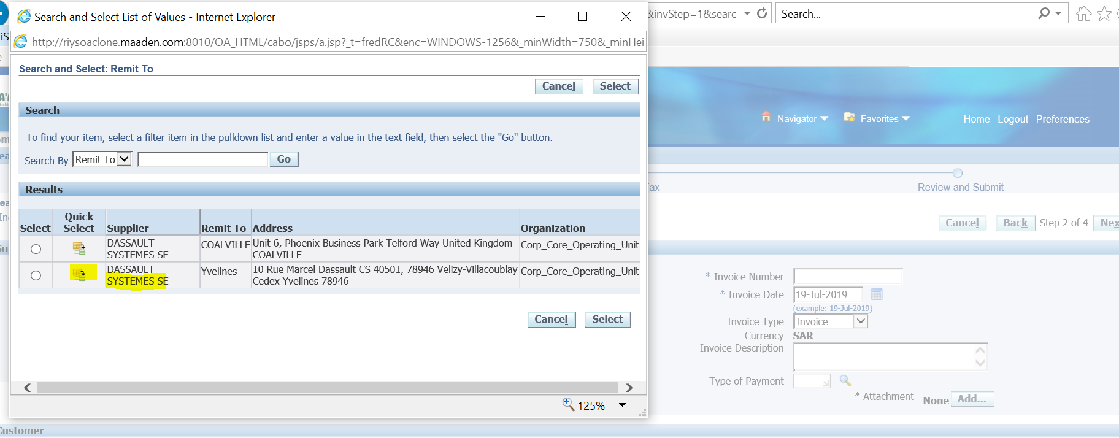

Select the Remit to Supplier

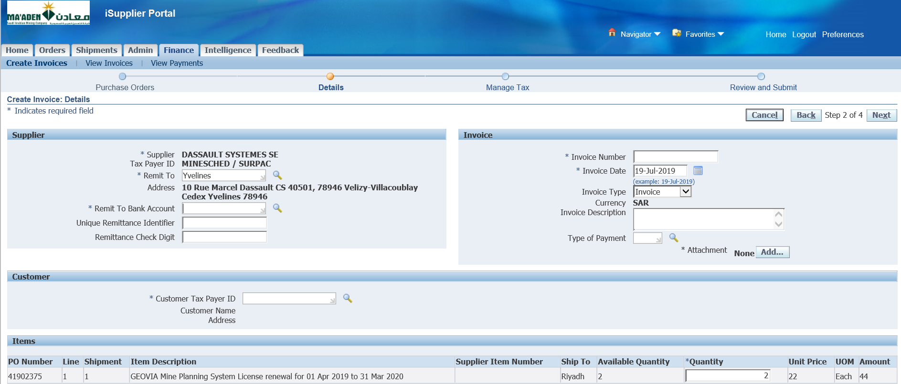

Select Remit to Bank Account

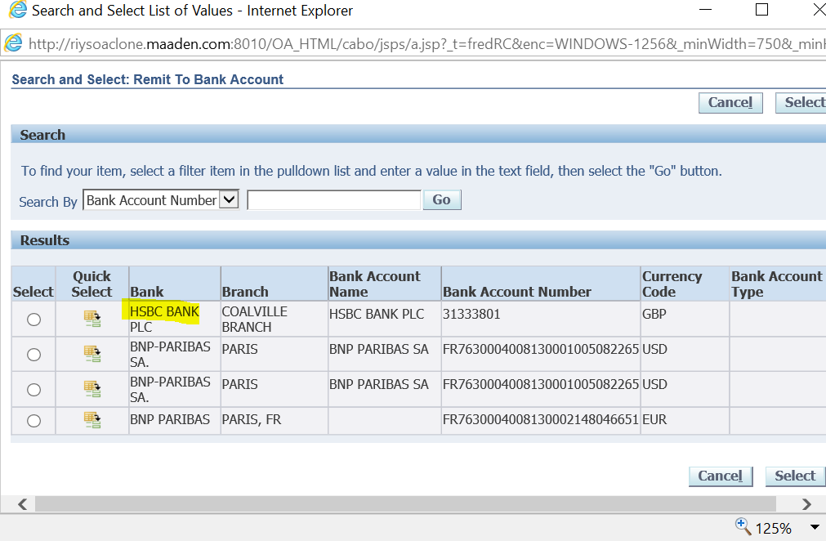

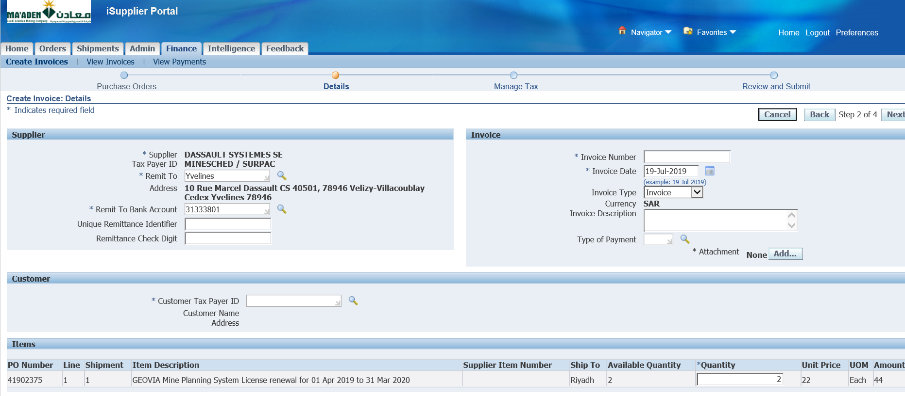

Select Customer Tax Payer ID

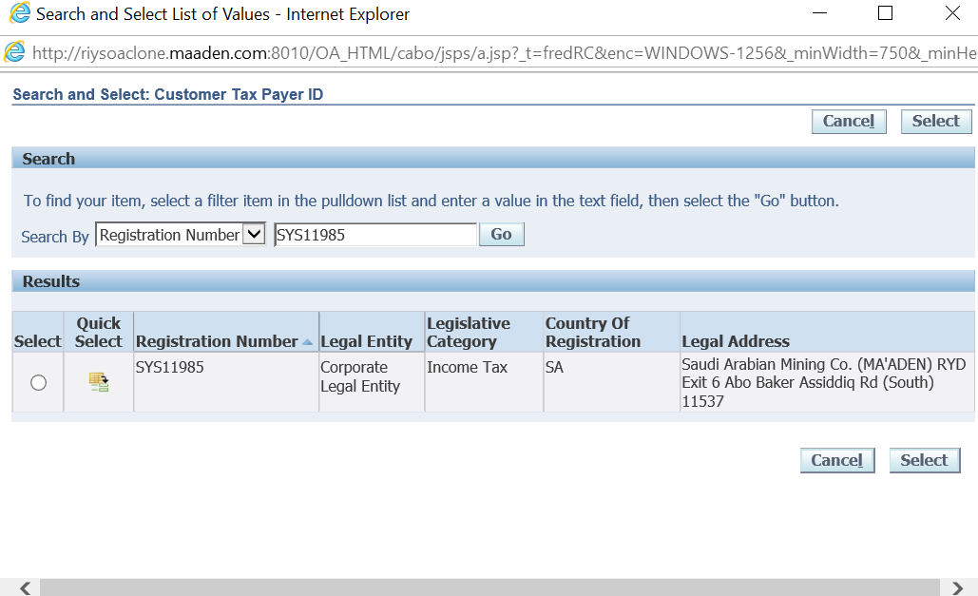

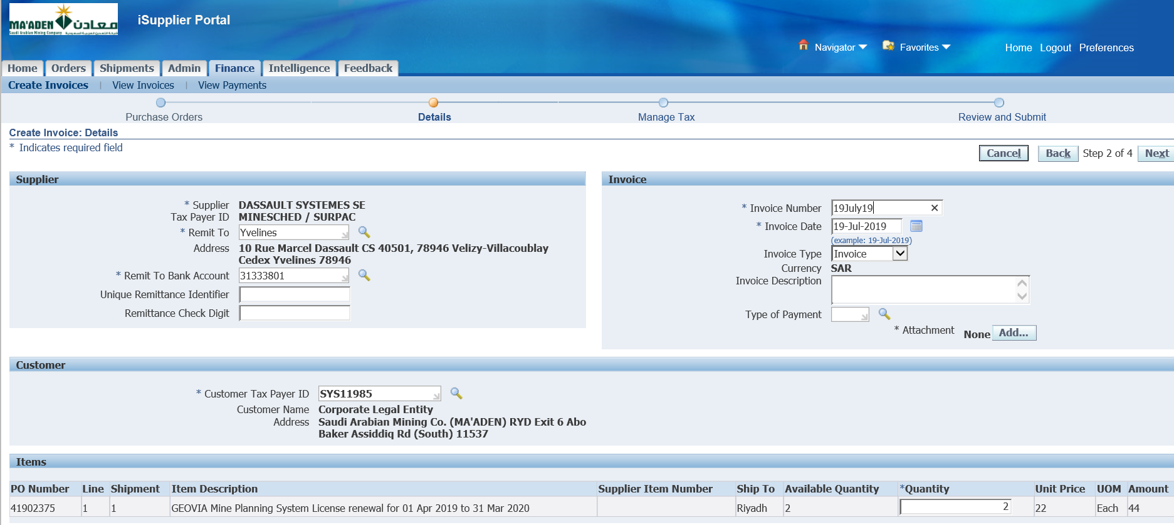

Manually Enter Invoice Num as above or even PO num

Add Attachment

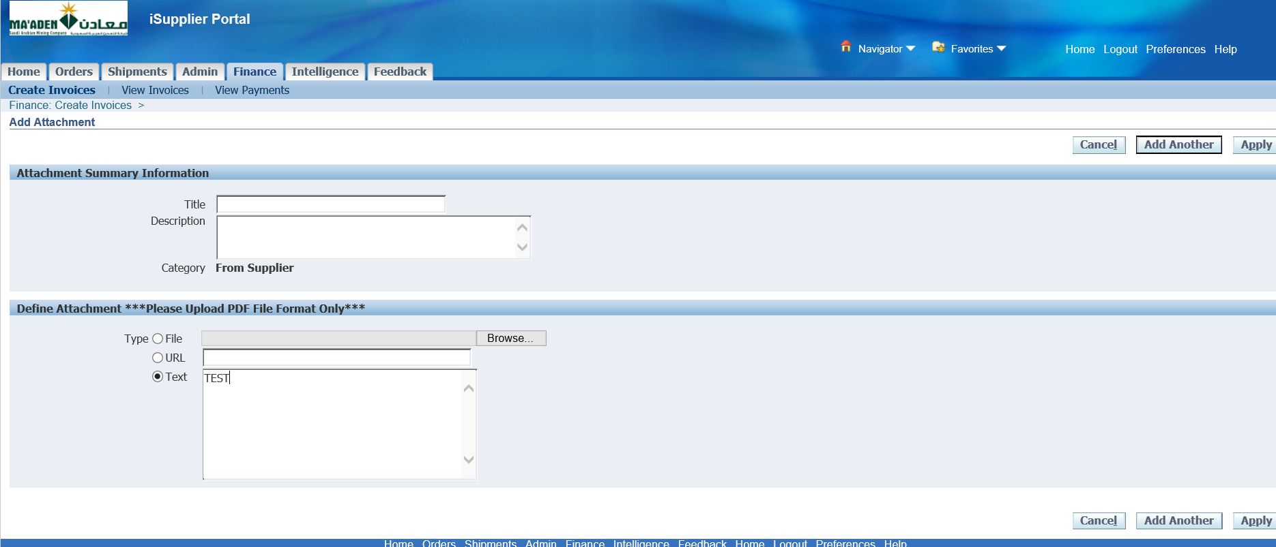

Select Text 🡪 Enter Some Text

Apply

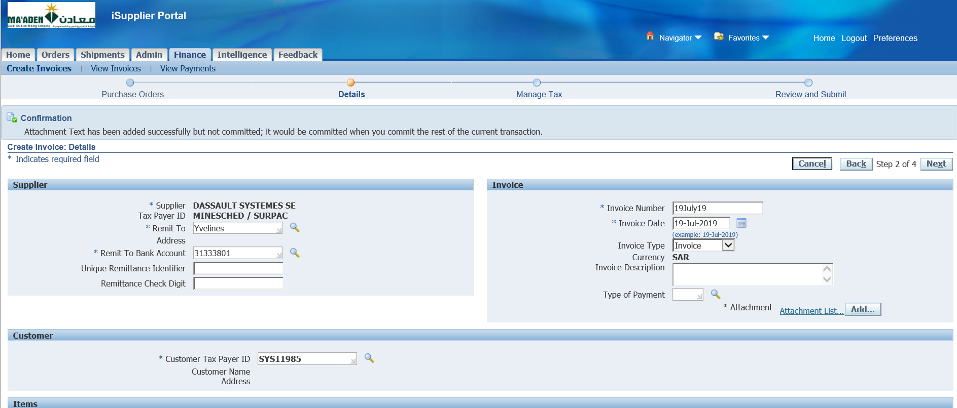

Next

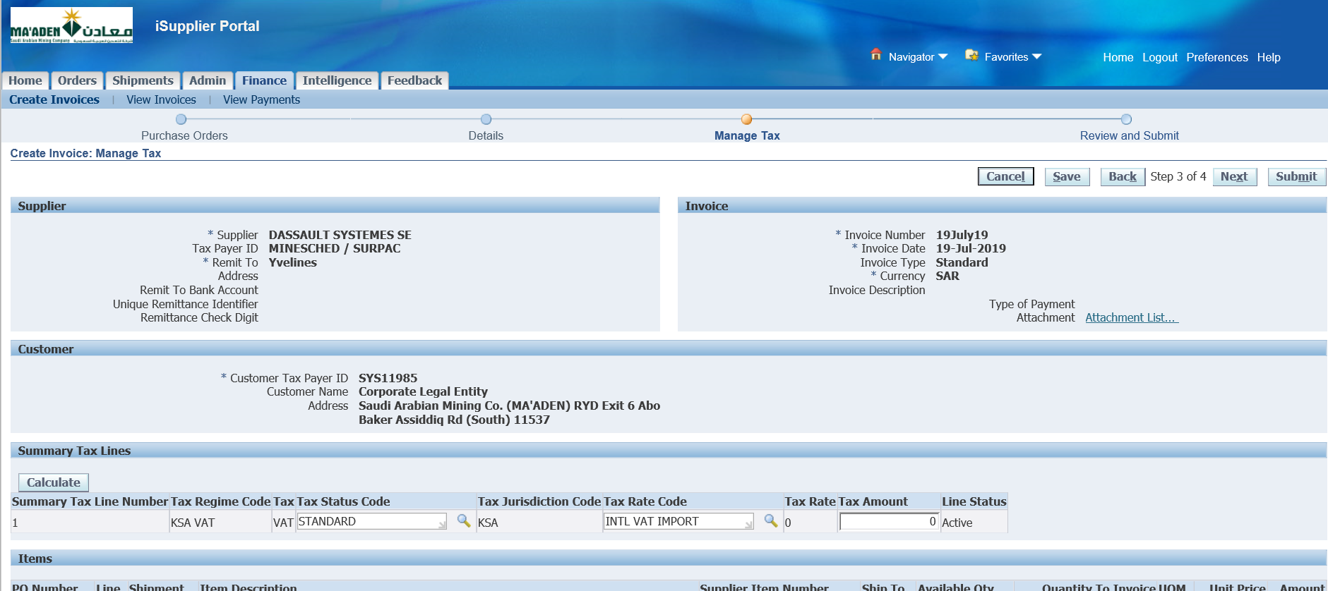

Submit

Invoice – 19July19

